Retailpulse Mini Project
#### STAGE 1 — DATA GENERATION (FOUNDATION)
1. Create Project Folder (LOCAL)
Create a folder as shown below:
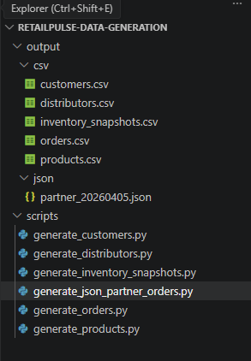
2. Install Required Python Libraries
Run once in terminal / command prompt:
pip install pandas faker numpy pytz
DATA GENERATION:
# Generate customers.csv
Script: scripts/generate_customers.py
import pandas as pd
import random
from faker import Faker

fake = Faker("en_IN")

ROWS = 1000

rows = []
for i in range(ROWS):
rows.append({
"customer_id": f"CUST{i+1:05d}",
"registration_date": fake.date_between(start_date="-2y", end_date="-10d"),
"city": fake.city(),
"state": fake.state(),
"pincode": fake.postcode() if random.random() > 0.1 else None,
"customer_segment": random.choice(["PREMIUM", "STANDARD", "BUDGET", "NEW"]),
"email_verified": random.choice([True, False]),
"phone_verified": random.choice([True, False]),
"loyalty_tier": random.choice(["GOLD", "SILVER", "BRONZE", "NONE", None]),
"acquisition_channel": random.choice(
["ORGANIC", "PAID_AD", "REFERRAL", "INFLUENCER", None]
),
"date_of_birth": fake.date_of_birth(minimum_age=18, maximum_age=65),
"gender": random.choice(
["MALE", "FEMALE", "OTHER", "PREFER_NOT_TO_SAY", None]
)
})

df = pd.DataFrame(rows)
df.to_csv("output/csv/customers.csv", index=False)

print("✅ customers.csv generated successfully")
# Generate products.csv
Script: scripts/generate_products.py
import pandas as pd
import random
from faker import Faker

fake = Faker("en_IN")

categories = {
"ELECTRONICS":["SMARTPHONES","LAPTOPS"],
"FASHION":["KURTI","JEANS"],
"GROCERY":["RICE","OIL"],
"HOME":["BEDDING","COOKWARE"],
"BEAUTY":["SKINCARE","MAKEUP"]
}

rows = []
for i in range(200):
cat = random.choice(list(categories))
sub = random.choice(categories[cat])
mrp = random.randint(200,30000)
cost = round(mrp * random.uniform(0.55,0.85),2)

rows.append({
"product_id": f"SKU{i+1:04d}",
"product_name": f"{fake.word().capitalize()} {sub}",
"category": cat,
"sub_category": sub,
"brand": fake.company(),
"base_mrp_inr": round(mrp,2),
"cost_price_inr": cost,
"weight_kg": round(random.uniform(0.1,5),3),
"is_active": True,
"launch_date": fake.date_between("-2y","today"),
"reorder_threshold": random.randint(10,50),
"return_window_days": random.choice([7,15,30])
})

pd.DataFrame(rows).to_csv("output/csv/products.csv", index=False)
print("✅ products.csv generated")
# Generate distributors.csv
Script: scripts/generate_distributors.py
import pandas as pd
import random
from faker import Faker

fake = Faker("en_IN")

rows = []
for i in range(10):
rows.append({
"distributor_id": f"DIST{i+1:02d}",
"distributor_name": fake.company(),
"region": random.choice(["NORTH","SOUTH","EAST","WEST","CENTRAL"]),
"state": fake.state(),
"city": fake.city(),
"tier": random.choice(["PRIMARY","SECONDARY","TERTIARY"]),
"contact_email": fake.email(),
"contact_phone": fake.phone_number(),
"is_active": True,
"onboarding_date": fake.date_between("-4y","-30d")
})

pd.DataFrame(rows).to_csv("output/csv/distributors.csv", index=False)
print("✅ distributors.csv generated")
# Generate orders.csv (WITH BAD DATA)
Includes duplicates, future dates, bad prices (needed for validation stage)
Script: scripts/generate_orders.py
import pandas as pd
import random
from datetime import datetime, timedelta
import pytz

IST = pytz.timezone("Asia/Kolkata")

rows = []
for i in range(5000):
odt = datetime.now(IST) - timedelta(days=random.randint(0,30))
rows.append({
"order_id": f"ORD{odt.strftime('%Y%m%d')}-{i:05d}",
"customer_id": f"CUST{random.randint(1,1000):05d}",
"order_date": odt,
"order_status": random.choice(
["PLACED","CONFIRMED","SHIPPED","DELIVERED","CANCELLED","RETURNED"]
),
"product_id": f"SKU{random.randint(1,200):04d}",
"quantity": random.randint(1,4),
"unit_price_inr": round(random.uniform(200,25000),2),
"mrp_inr": round(random.uniform(200,30000),2),
"discount_code": random.choice([None,"SALE10","FESTIVE"]),
"payment_method": random.choice(
["UPI","CREDIT_CARD","DEBIT_CARD","NET_BANKING","COD","WALLET"]
),
"delivery_pincode": str(random.randint(100000,999999)),
"distributor_id": f"DIST{random.randint(1,10):02d}",
"platform": random.choice(
["APP_ANDROID","APP_IOS","WEB_DESKTOP","WEB_MOBILE"]
),
"created_at": odt
})

pd.DataFrame(rows).to_csv("output/csv/orders.csv", index=False)
print("✅ orders.csv generated")
# Generate inventory_snapshots.csv
Includes negative stock & imbalance
Script: scripts/generate_inventory_snapshots.py
import pandas as pd
import random
from datetime import date

rows = []
for d in range(1,11):
for p in range(1,201):
opening = random.randint(0,60)
received = random.randint(0,40)
dispatched = random.randint(0,80)

rows.append({
"snapshot_id": f"{date.today()}_DIST{d}_SKU{p}",
"snapshot_date": date.today(),
"distributor_id": f"DIST{d:02d}",
"product_id": f"SKU{p:04d}",
"opening_stock": opening,
"units_received": received,
"units_dispatched": dispatched,
"units_returned": random.randint(0,5),
"units_damaged": random.randint(0,2),
"closing_stock": opening + received - dispatched,
"reorder_point": random.randint(10,50)
})

pd.DataFrame(rows).to_csv("output/csv/inventory_snapshots.csv", index=False)
print("✅ inventory_snapshots.csv generated")
# Generate partner_20260405.json
Includes negative stock & imbalance
Script: scripts/generate_ json_partners_orders.py
import json
import random
from datetime import datetime, timedelta
import pytz

UTC = pytz.utc

orders = []

for i in range(500):
placed_at = datetime.now(UTC) - timedelta(days=random.randint(0,5))
orders.append({
"order_ref": f"ORD{placed_at.strftime('%Y%m%d')}-{i:05d}",
"cust_id": f"CUST{random.randint(1,1000):05d}",
"placed_at": placed_at.isoformat(),
"status": random.choice(["placed","confirmed","shipped","delivered","cancelled","returned"]),
"sku": f"SKU{random.randint(1,200):04d}",
"qty": random.randint(1,3),
"sale_price": round(random.uniform(200,25000),2),
"listed_price": round(random.uniform(200,30000),2),
"promo_code": random.choice([None,"PARTNER10"]),
"payment": {
"method": random.choice(["UPI","COD","CARD"])
},
"delivery": {
"pin": str(random.randint(100000,999999))
},
"fulfil_by": f"DIST{random.randint(1,10):02d}",
"channel": random.choice(["app","web"])
})

with open("output/json/partner_20260405.json","w") as f:
json.dump(orders,f,indent=2)

print("✅ Partner JSON orders generated")
✅ END OF STAGE 1 — CHECKPOINT
You should now have 5 CSV files here:
output/csv/
├── customers.csv
├── products.csv
├── distributors.csv
├── orders.csv
└── inventory_snapshots.csv
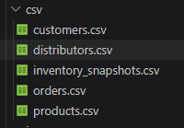
======================================================================

#### STAGE 2 — AMAZON S3 DATA LAKE SETUP
1. Create Bucket
Click Create bucket
Fill exactly:
Setting | Value
Bucket name | retailpulse-data-lake-ankita
Region | ap-south-1 (Mumbai)
Bucket type | General purpose
Block Public Access | ✅ ON (default)
Versioning | ❌ OFF (keep cost low)
Encryption | ✅ SSE-S3 (default)
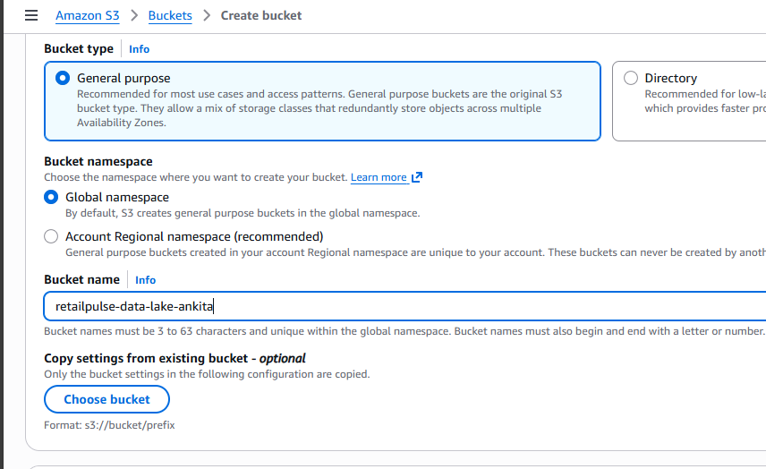
Click Create bucket
2. Create Data Lake Folder Structure
Inside retailpulse-data-lake, create:
raw/
├── rds/
│ ├── orders/
│ ├── customers/
│ ├── products/
│ ├── distributors/
│ └── inventory_snapshots/
│
├── orders_json/
│
processed/
├── facts/
│ └── orders/
│
├── dimensions/
│ ├── customers/
│ ├── products/
│ └── distributors/
│
quarantine/
├── null_key/
├── future_date/
├── duplicates/
├── invalid_status/
│
aggregates/
├── customer_metrics/
└── product_daily/
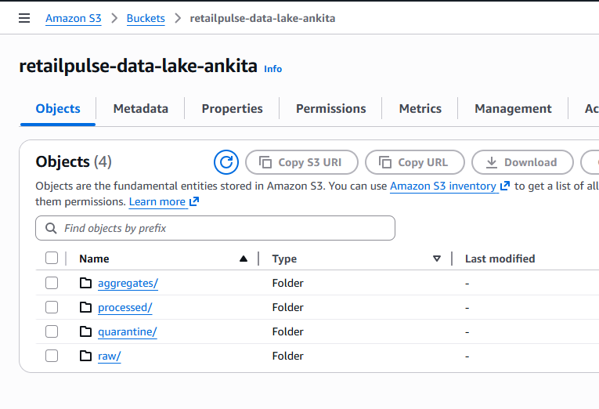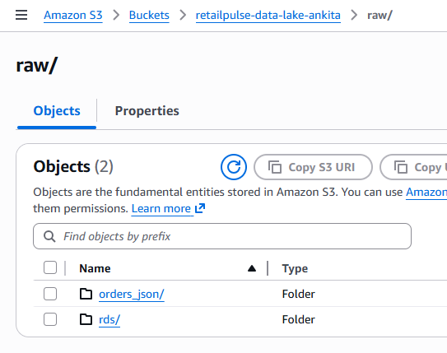
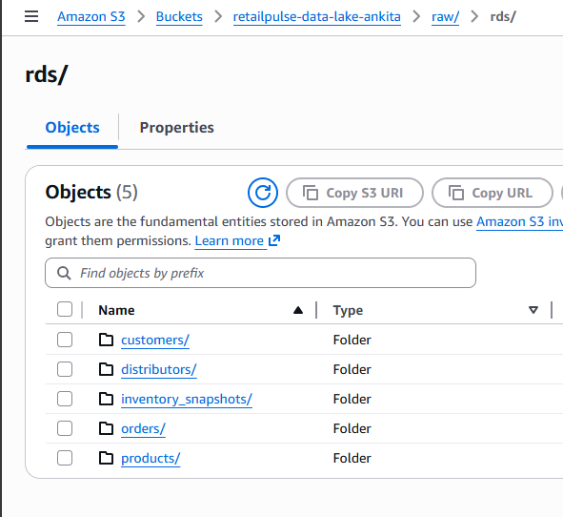
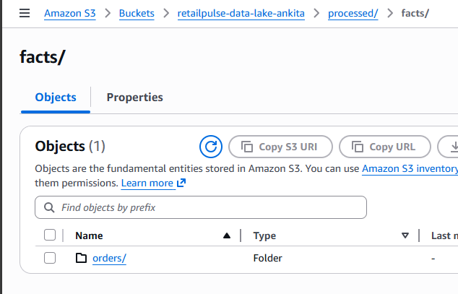
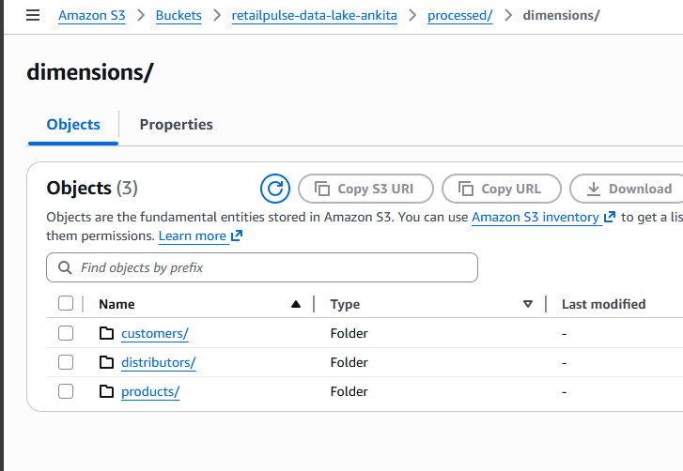
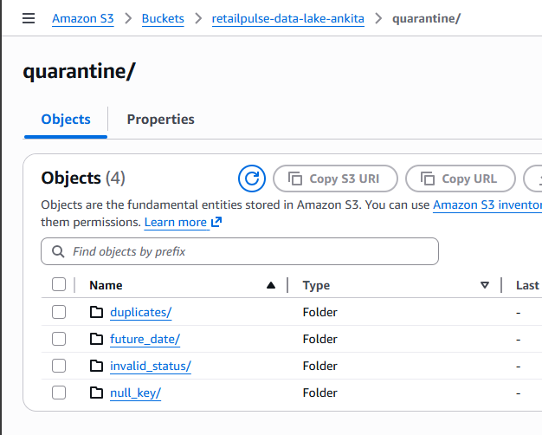
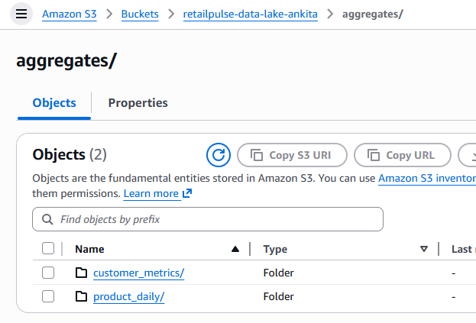
3. Create Folders
Open bucket - Create folder
Create folders one by one, respecting hierarchy:
- raw/
- raw/rds/orders/
- raw/rds/customers/
- raw/rds/products/
- raw/rds/distributors/
- raw/rds/inventory_snapshots/
- raw/orders_json/
- processed/
- processed/facts/orders/
- processed/dimensions/customers/
- processed/dimensions/products/
- processed/dimensions/distributors/
- quarantine/
- aggregates/customer_metrics/
- aggregates/product_daily/
Do NOT improvise names — exact spelling matters later.
4. Upload Your CSV Files (RAW ZONE)
5. Upload Customers CSV
Navigate to:
retailpulse-data-lake → raw → rds → customers
Click Upload → Add file
Upload:
customers.csv
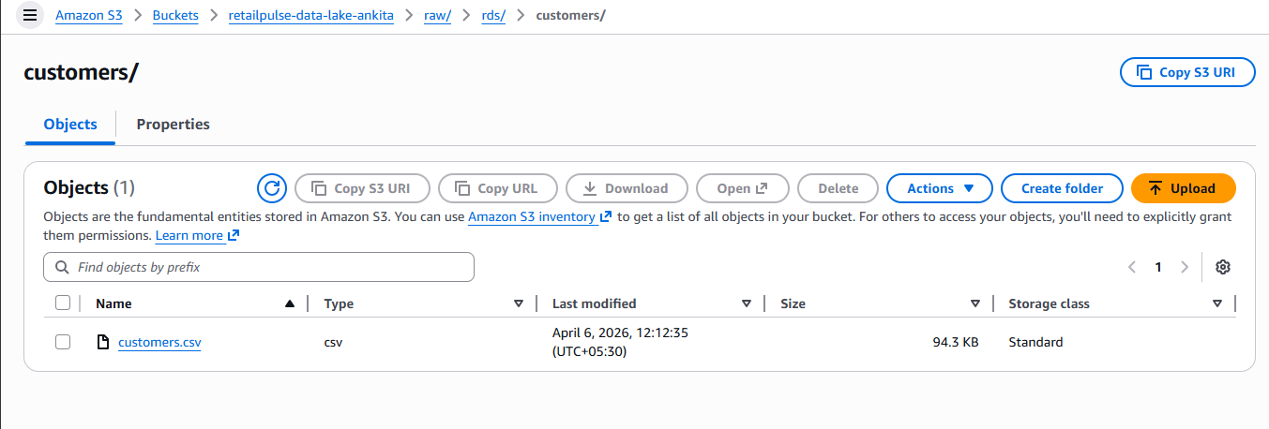
Click Upload
6. Upload Products CSV
Path:
raw/rds/products/
Upload:
products.csv
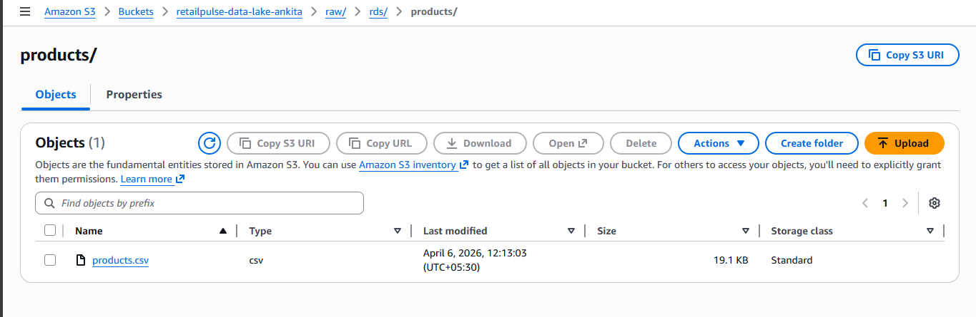
7. Upload Distributors CSV
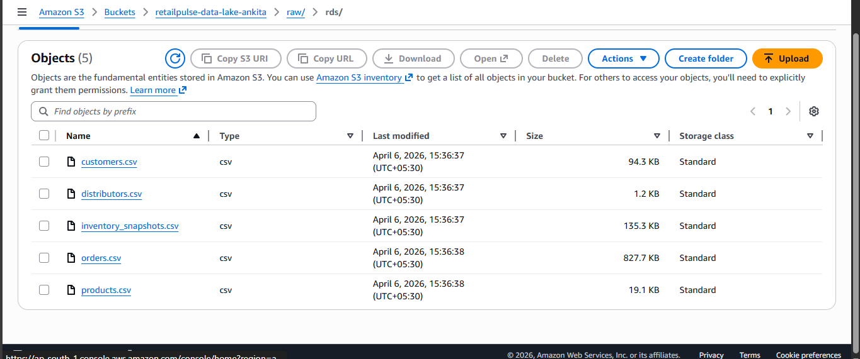
Path:
raw/rds/distributors/
Upload:
distributors.csv
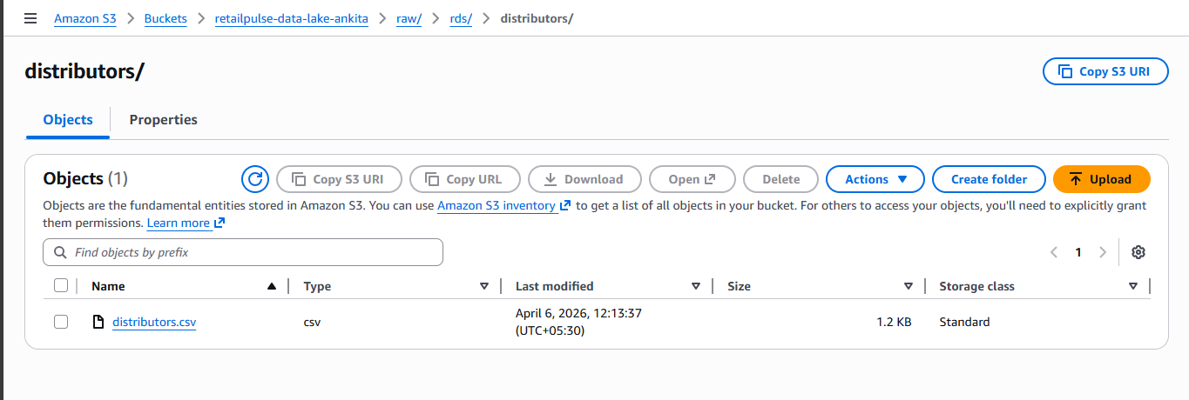
8. Upload Orders CSV
Path: raw/rds/orders/
Upload: orders.csv
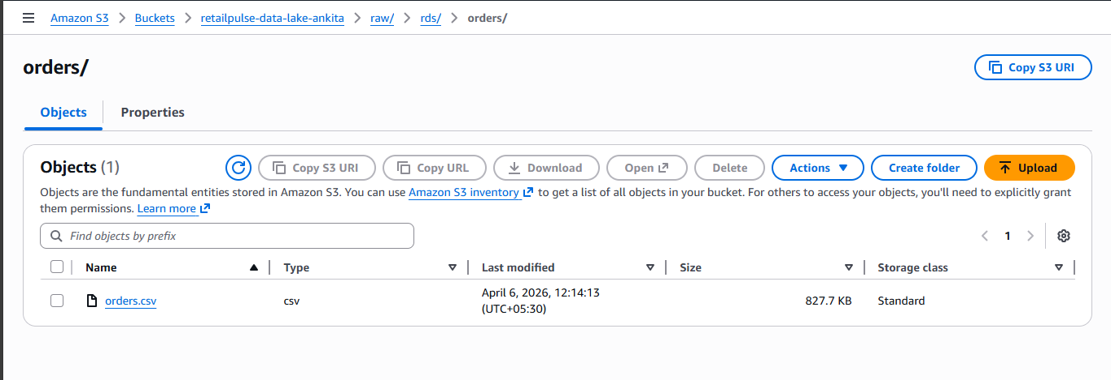
9. Upload Inventory Snapshots CSV
Path: raw/rds/inventory_snapshots/
Upload: inventory_snapshots.csv
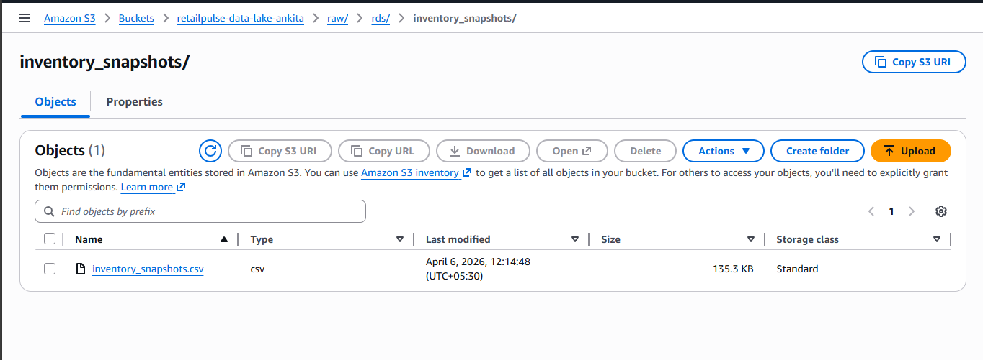
10. Upload Partner JSON Orders
Navigate to: raw/orders_json/
Upload: partner_20260405.json
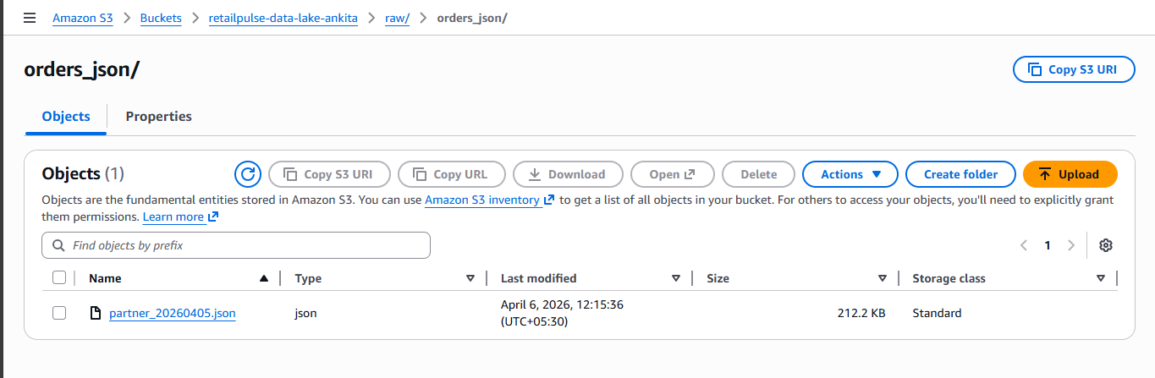
======================================================================

#### STAGE 3 - AMAZON RDS (MySQL) SETUP + SCHEMA + DATA LOAD
Create RDS MySQL Instance
Step 1: Open RDS
AWS Console → Search → RDS
Click Create database
Step 2: Database Creation Options
Choose Standard create
Engine options:
- Engine: MySQL
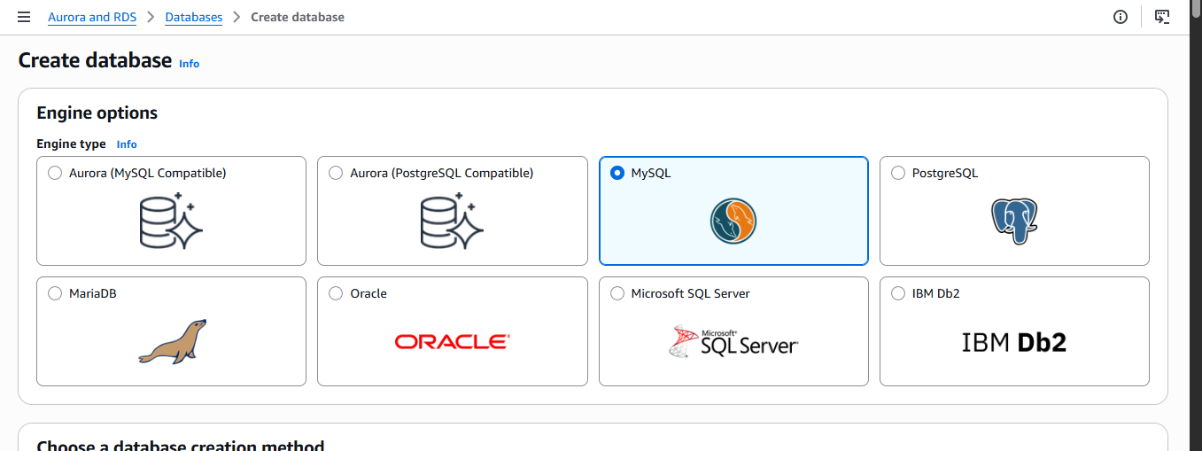
- Version: MySQL 8.0.x (default)
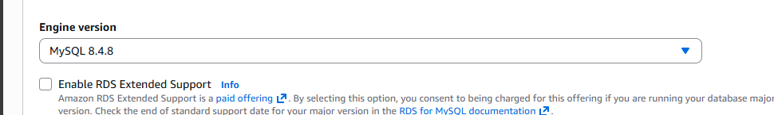
Step 3: Templates
Choose: Free tier
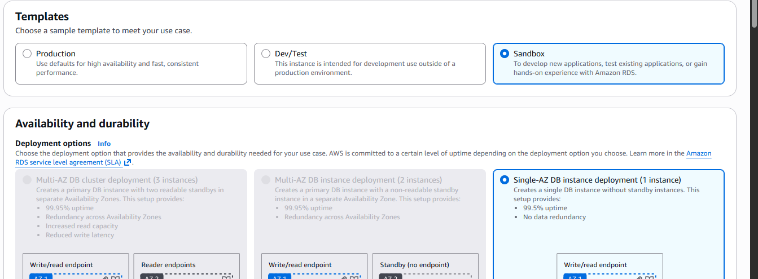
Step 4: Settings
Field | Value
DB instance identifier | ankita-retailpulse-mysql
Master username | admin
Master password | 12345678
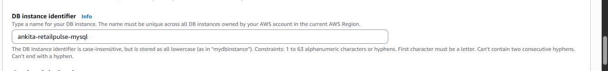
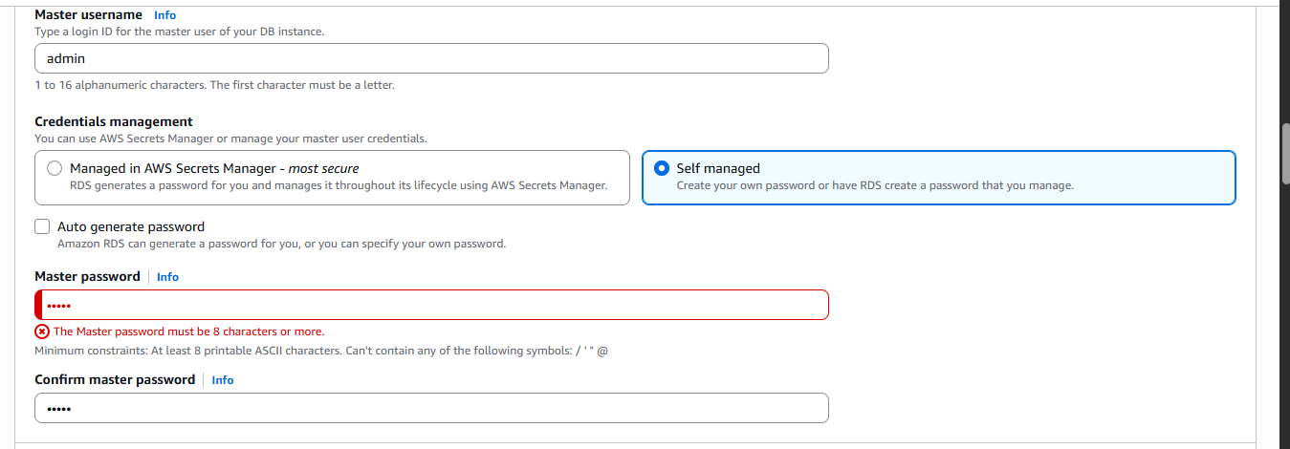
Step 5: Instance Configuration
Setting | Value
DB instance class | db.t3.micro
Storage | 20 GB (default)
Autoscaling | ❌ Disabled
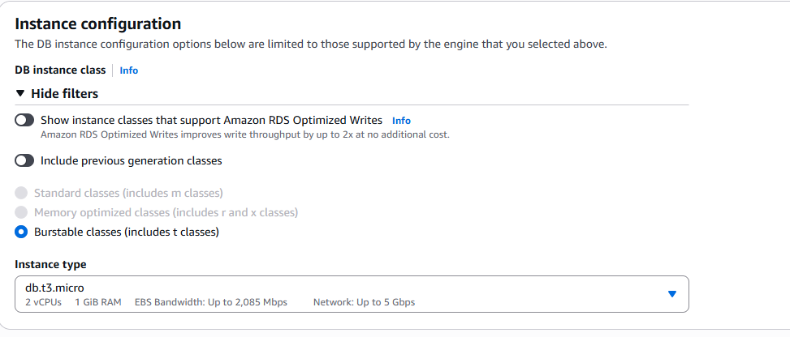
Step 6: Connectivity (VERY IMPORTANT)
- VPC: Default
- Public access: Yes
- VPC security group: Create new
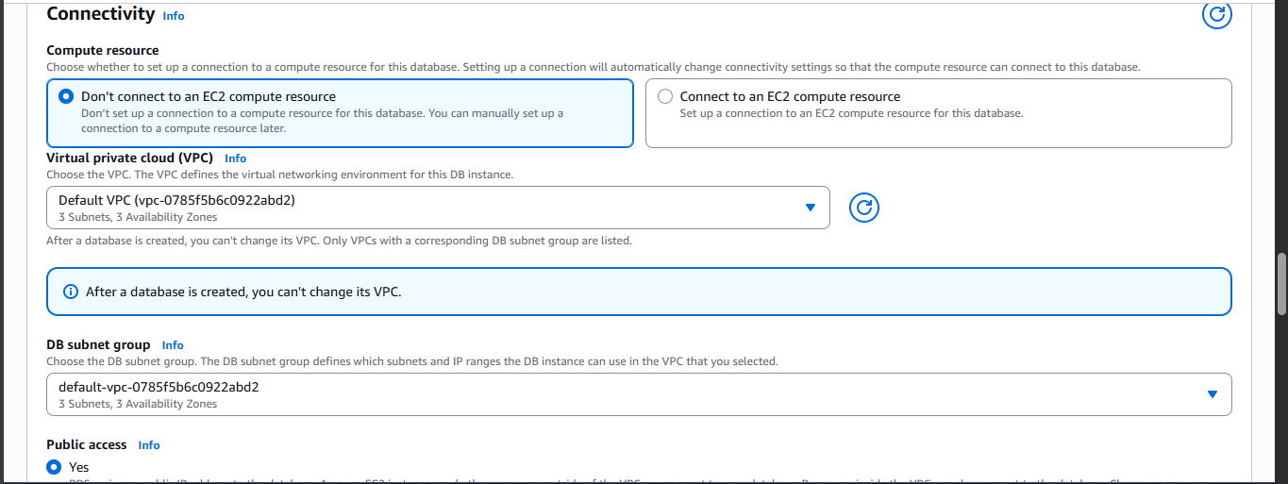
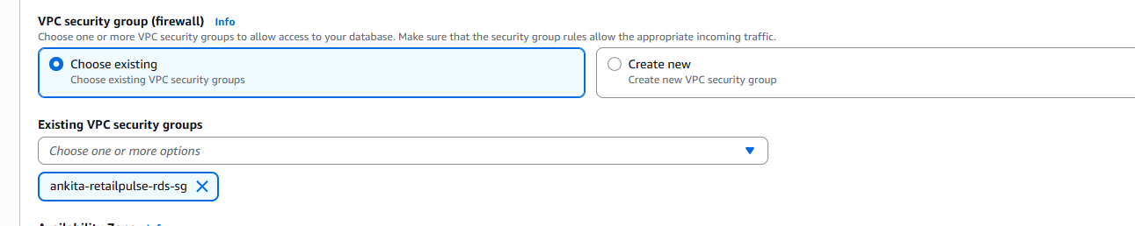
Security group name: ankita-retailpulse-rds-sg
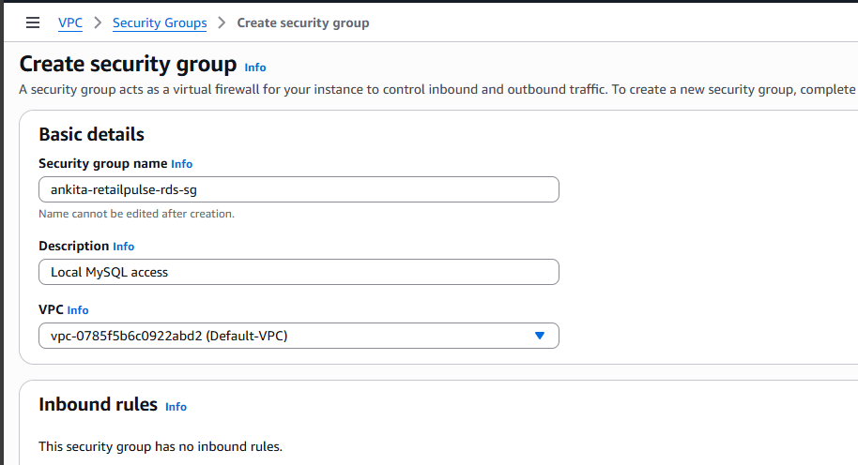
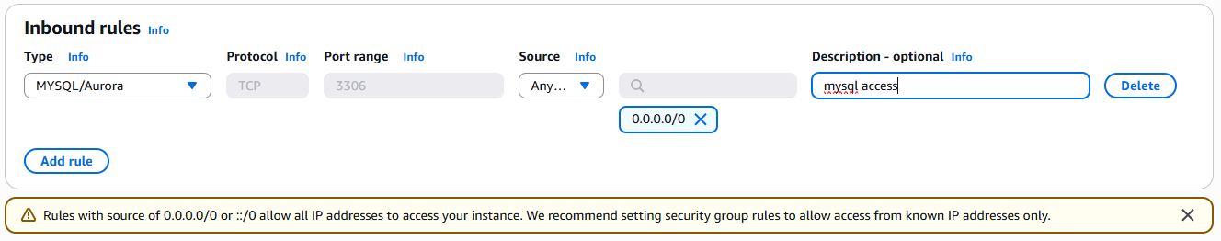
Step 7: Additional Configuration
Expand Additional Configuration
Setting | Value
Initial database name | retailpulse
Backup | Disabled
Encryption | Disabled
Deletion protection | ❌ Disabled
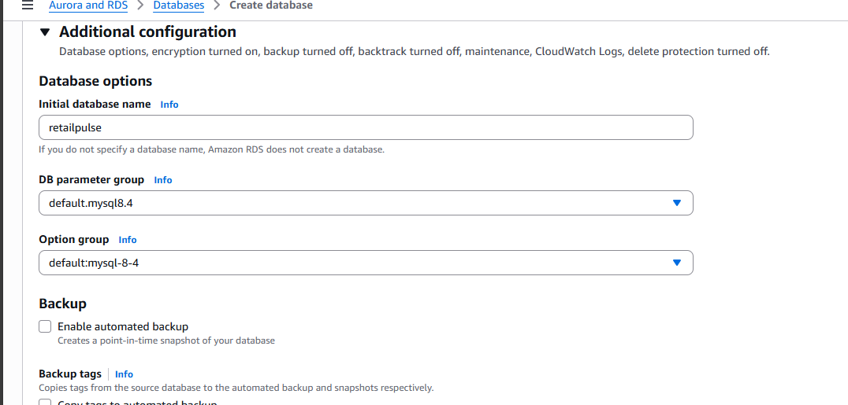
Click Create database
Wait ~5–7 minutes → Status = Available
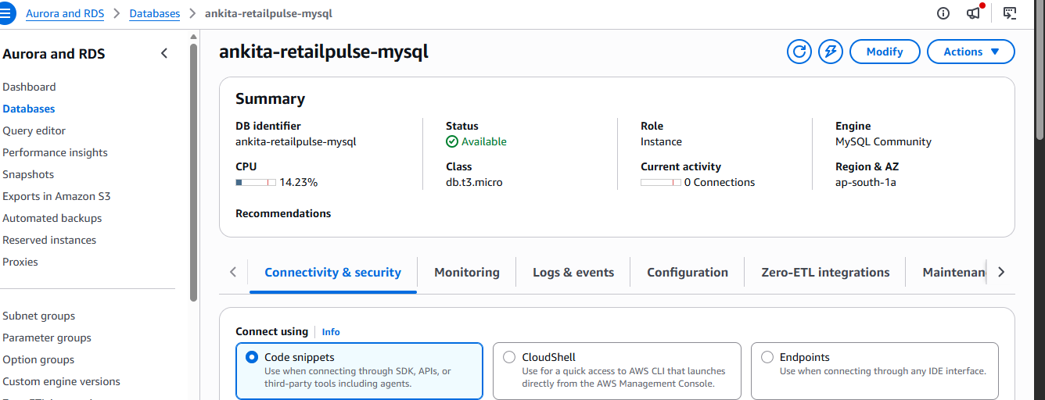
Allow Your Laptop to Connect (Security Group Rule)
Step 8: Open RDS Security Group
RDS → Databases → retailpulse-mysql
Click Connectivity & Security
Click Security Group
Step 9: Add Inbound Rule
Edit inbound rules → Add rule:
Setting | Value
Type | MySQL/Aurora
Port | 3306
Source | My IP
Description | Local MySQL access
Save rules
4.4 Connect to RDS MySQL Using an EC2 Instance
STEP 1 — Launch an EC2 Instance
- Open EC2 Service
AWS Console → Search EC2 → Click EC2
- Launch Instance
Click Launch instance
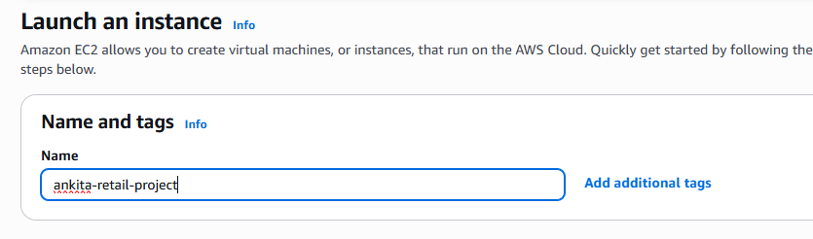
- Choose AMI (OS)
Select: Amazon Linux 2023 AMI
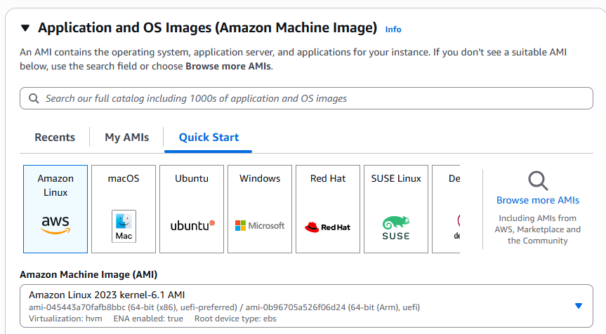
- Choose Instance Type
Select: t2.micro (or t3.micro)
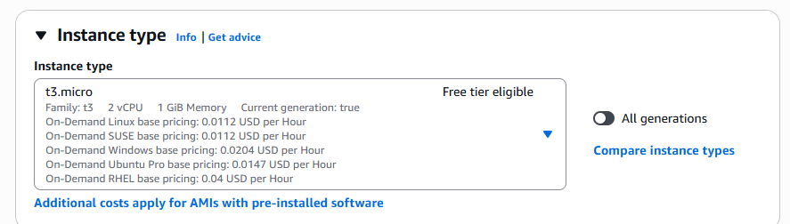
- Key Pair (VERY IMPORTANT)
Choose one:
- Create new key pair
- Name: retailpulse-ec2-key
- Type: RSA
- Format: .pem
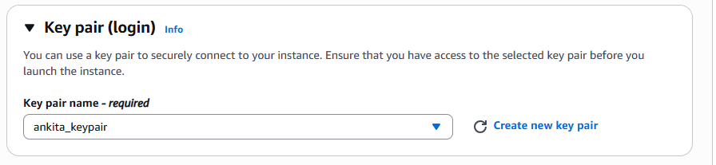
- Network Settings (IMPORTANT)
Setting | Value
VPC | Default
Subnet | Same VPC as RDS
Auto-assign Public IP | ✅ Enable
Security Group | Create new
Security Group name: ankita-retailpulse-ec2-sg
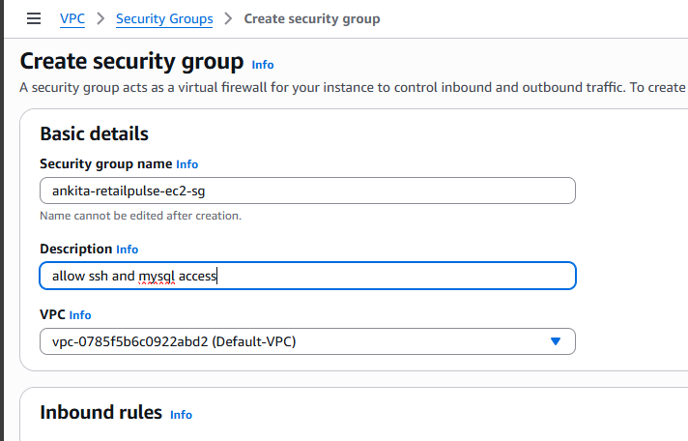
Inbound rule:
Type | Port | Source
SSH | 22 | My IP
MySQL / Aurora | 3306 | EC2 Security Group (retailpulse-ec2-sg)
This allows to SSH and mysql
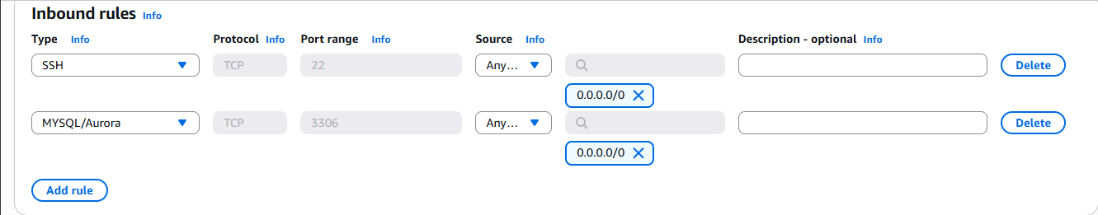
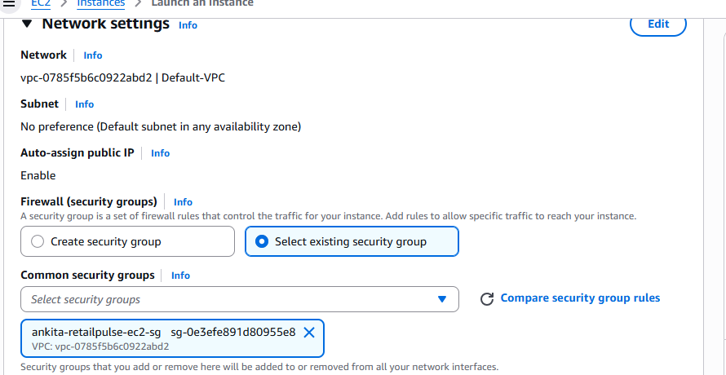
- Launch Instance
Click Launch instance
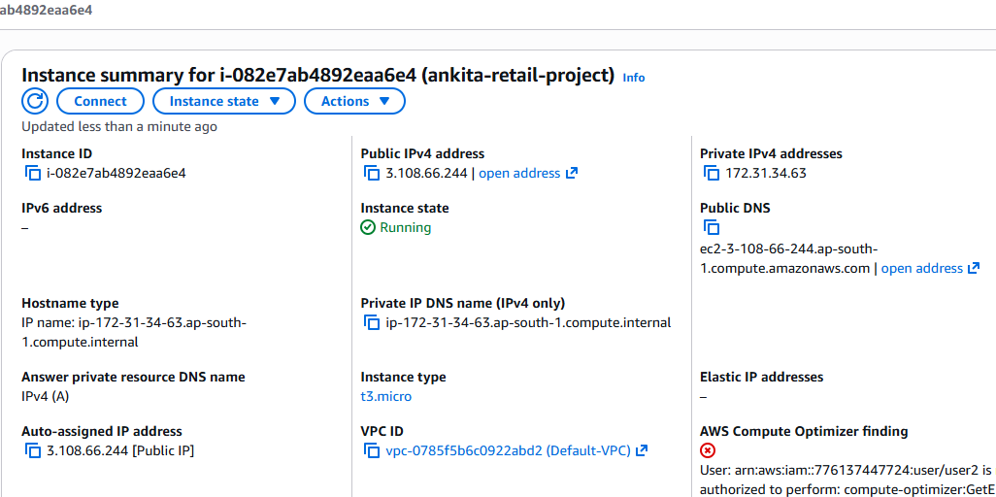
SSH from Your Laptop
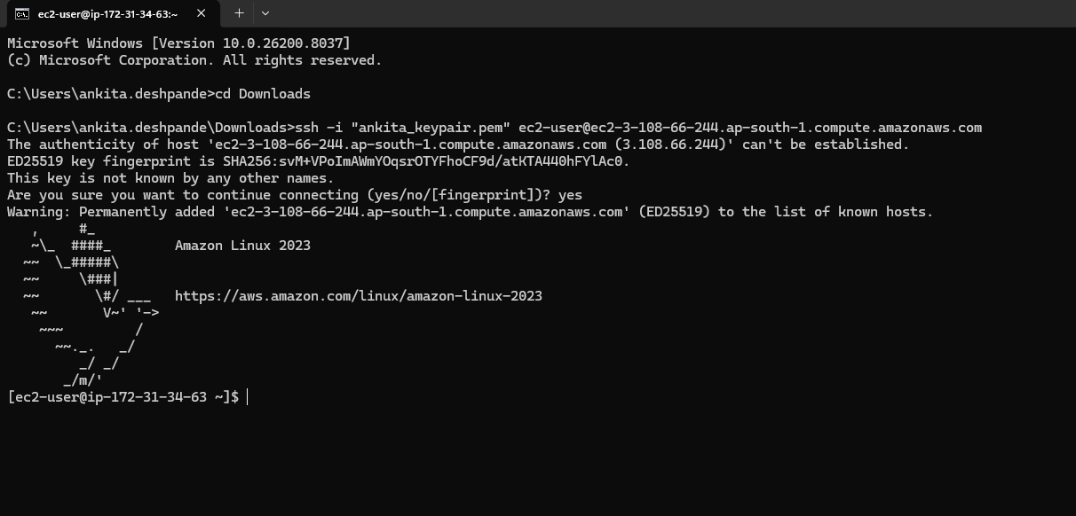
## Install MySQL Client on EC2
Amazon Linux does not ship with MySQL client preinstalled.
# Install MySQL Client
Run: sudo dnf update -y
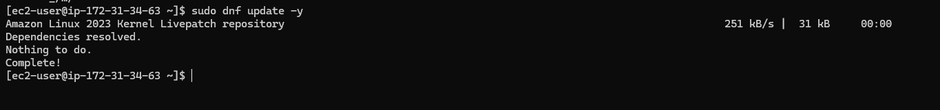
sudo dnf install mariadb105 -y
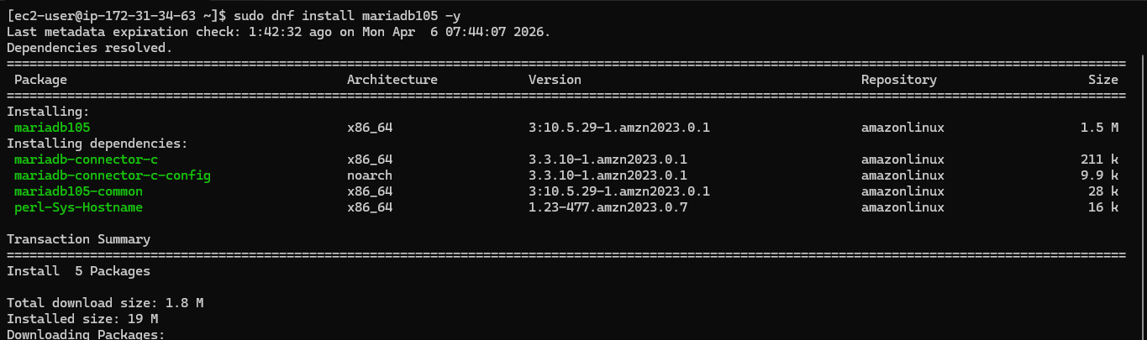
Verify: mysql –version
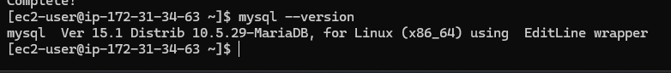
## Connect from EC2 to RDS MySQL
# Get RDS Endpoint
From RDS console:
ankita-retailpulse-mysql.c58qessmggt4.ap-south-1.rds.amazonaws.com
Connect Using MySQL Client
mysql -h <RDS_ENDPOINT> -P 3306 -u admin -p
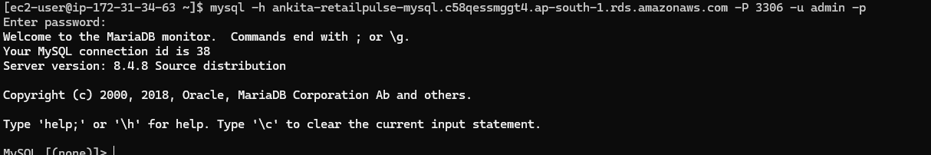
Command:
mysql -h ankita-retailpulse-mysql.c58qessmggt4.ap-south-1.rds.amazonaws.com -P 3306 -u admin -p
Enter password when prompted.
You should see: mysql>
## Verify Connection
Run:
SHOW DATABASES;
USE retailpulse;
SHOW TABLES;
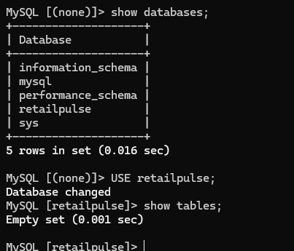
### Create Database Schema & Tables
We now enforce all datatypes from the PRD.
1. Create Schema (if not auto-created)
CREATE DATABASE IF NOT EXISTS retailpulse;
USE retailpulse;
2. Create customers Table
CREATE TABLE customers (
customer_id VARCHAR(30) PRIMARY KEY,
registration_date DATE NOT NULL,
city VARCHAR(80) NOT NULL,
state VARCHAR(50) NOT NULL,
pincode VARCHAR(10),
customer_segment VARCHAR(20) NOT NULL,
email_verified BOOLEAN NOT NULL,
phone_verified BOOLEAN NOT NULL,
loyalty_tier VARCHAR(15),
acquisition_channel VARCHAR(30),
date_of_birth DATE,
gender VARCHAR(10)
);
3. Create products Table
CREATE TABLE products (
product_id VARCHAR(30) PRIMARY KEY,
product_name VARCHAR(200) NOT NULL,
category VARCHAR(50) NOT NULL,
sub_category VARCHAR(80),
brand VARCHAR(80),
base_mrp_inr DECIMAL(10,2) NOT NULL,
cost_price_inr DECIMAL(10,2) NOT NULL,
weight_kg DECIMAL(6,3),
is_active BOOLEAN NOT NULL,
launch_date DATE NOT NULL,
reorder_threshold INT NOT NULL,
return_window_days INT NOT NULL
);
4. Create distributors Table
CREATE TABLE distributors (
distributor_id VARCHAR(20) PRIMARY KEY,
distributor_name VARCHAR(150) NOT NULL,
region VARCHAR(30) NOT NULL,
state VARCHAR(50) NOT NULL,
city VARCHAR(80) NOT NULL,
tier VARCHAR(15) NOT NULL,
contact_email VARCHAR(100),
contact_phone VARCHAR(20),
is_active BOOLEAN NOT NULL,
onboarding_date DATE NOT NULL
);
5. Create orders Table
CREATE TABLE orders (
order_id VARCHAR(40) PRIMARY KEY,
customer_id VARCHAR(30) NOT NULL,
order_date DATETIME NOT NULL,
order_status VARCHAR(20) NOT NULL,
product_id VARCHAR(30) NOT NULL,
quantity INT NOT NULL,
unit_price_inr DECIMAL(10,2) NOT NULL,
mrp_inr DECIMAL(10,2) NOT NULL,
discount_code VARCHAR(20),
payment_method VARCHAR(20) NOT NULL,
delivery_pincode VARCHAR(10) NOT NULL,
distributor_id VARCHAR(20) NOT NULL,
platform VARCHAR(15) NOT NULL,
created_at DATETIME NOT NULL
);
6. Create inventory_snapshots Table
CREATE TABLE inventory_snapshots (
snapshot_id VARCHAR(40) PRIMARY KEY,
snapshot_date DATE NOT NULL,
distributor_id VARCHAR(20) NOT NULL,
product_id VARCHAR(30) NOT NULL,
opening_stock INT NOT NULL,
units_received INT NOT NULL,
units_dispatched INT NOT NULL,
units_returned INT NOT NULL,
units_damaged INT NOT NULL,
closing_stock INT NOT NULL,
reorder_point INT NOT NULL
);
Verify:
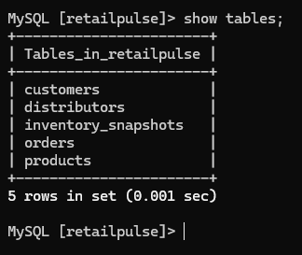
## Load CSV Data into RDS
# Load Customers CSV
Step 1: Download CSV from S3 to EC2
From your EC2 SSH session:
1. aws s3 cp s3://retailpulse-data-lake-ankita/raw/rds/customers.csv /tmp/customers.csv
Verify: ls -lh /tmp/customers.csv
2. aws s3 cp s3://retailpulse-data-lake-ankita/raw/rds/distributors.csv /tmp/distributors.csv
Verify: ls -lh /tmp/distributors.csv
3. aws s3 cp s3://retailpulse-data-lake-ankita/raw/rds/inventory_snapshots.csv /tmp/inventory_snapshots.csv
Verify: ls -lh /tmp/inventory_snapshots.csv
4. aws s3 cp s3://retailpulse-data-lake-ankita/raw/rds/orders.csv /tmp/orders.csv
Verify: ls -lh /tmp/orders.csv
5. aws s3 s3://retailpulse-data-lake-ankita/raw/rds/products.csv /tmp/products.csv
Verify: ls -lh /tmp/products.csv
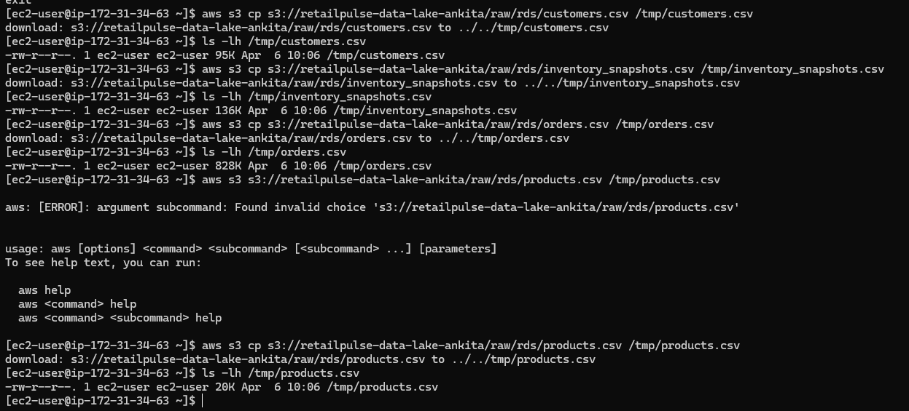
Step 2: Load LOCAL file into MySQL
Now run this command in MySQL:
1. customer.csv
LOAD DATA LOCAL INFILE '/tmp/customers.csv'
INTO TABLE customers
FIELDS TERMINATED BY ','
ENCLOSED BY '"'
LINES TERMINATED BY '\n'
IGNORE 1 ROWS;
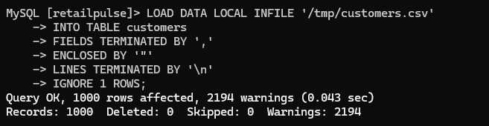
Verify:
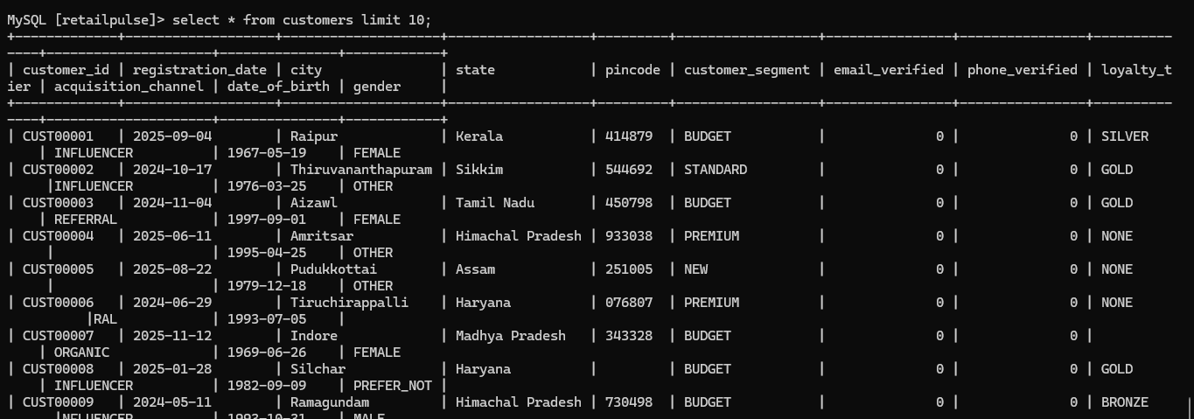
2. distributors.csv
LOAD DATA LOCAL INFILE '/tmp/distributors.csv'
INTO TABLE distributors
FIELDS TERMINATED BY ','
ENCLOSED BY '"'
LINES TERMINATED BY '\n'
IGNORE 1 ROWS;
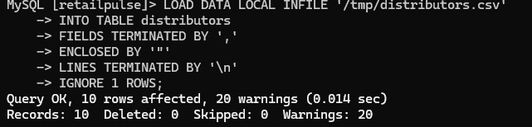
Verify:
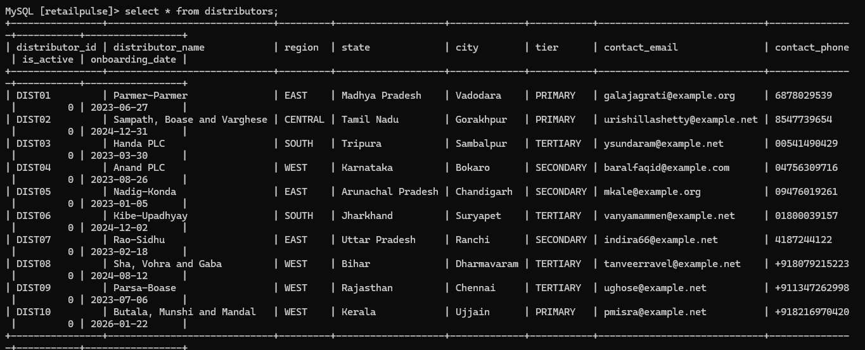
3. inventory_snapshots.csv
LOAD DATA LOCAL INFILE '/tmp/inventory_snapshots.csv'
INTO TABLE inventory_snapshots
FIELDS TERMINATED BY ','
ENCLOSED BY '"'
LINES TERMINATED BY '\n'
IGNORE 1 ROWS;
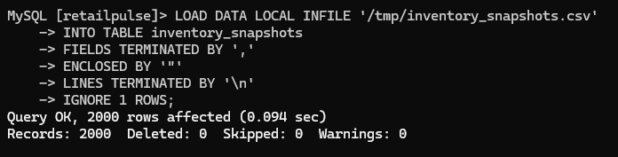
Verify:
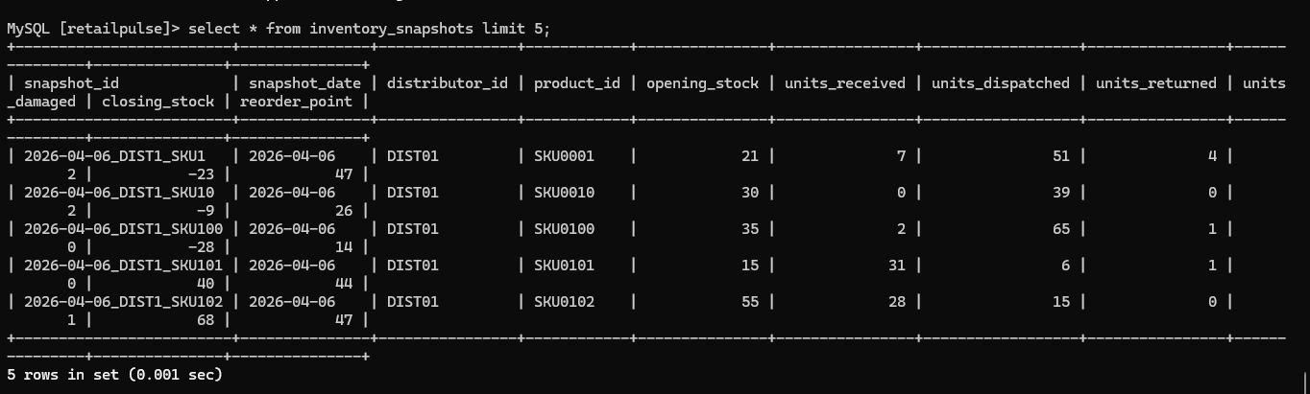
4. customer.csv
LOAD DATA LOCAL INFILE '/tmp/orders.csv'
INTO TABLE orders
FIELDS TERMINATED BY ','
ENCLOSED BY '"'
LINES TERMINATED BY '\n'
IGNORE 1 ROWS;
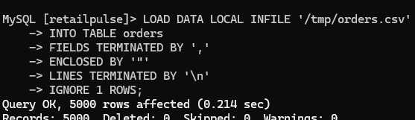
Verify:
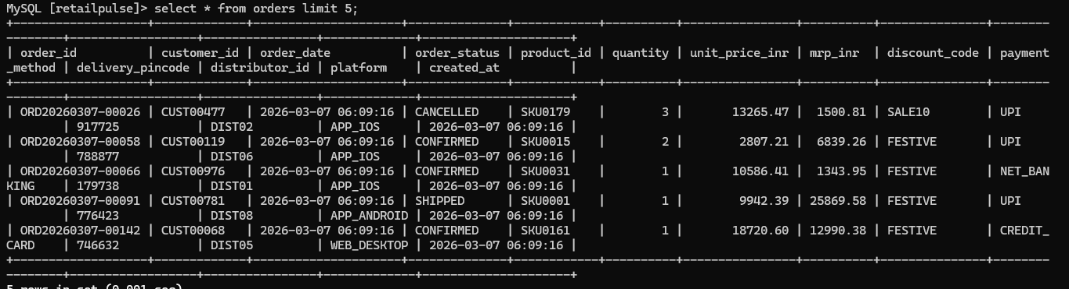
5. customer.csv
LOAD DATA LOCAL INFILE '/tmp/products.csv'
INTO TABLE products
FIELDS TERMINATED BY ','
ENCLOSED BY '"'
LINES TERMINATED BY '\n'
IGNORE 1 ROWS;
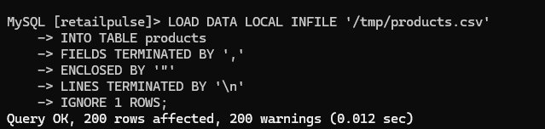
Verify:
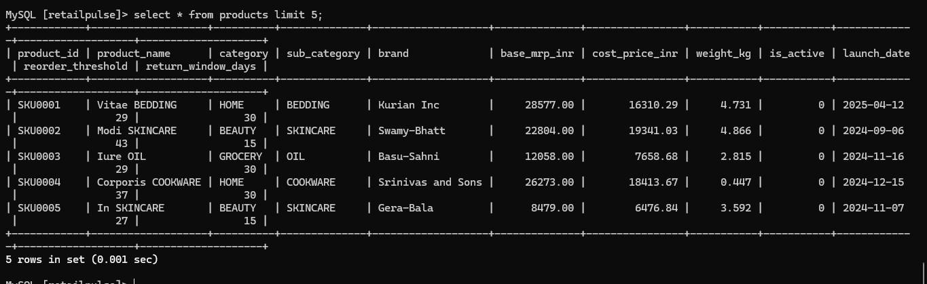
======================================================================

#### STAGE 4 - AMAZON EMR CLUSTER–BASED ETL
5.4 Create the EMR Spark Script
File name: retailpulse_emr_etl.py
from pyspark.sql import SparkSession
from pyspark.sql.functions import *
from pyspark.sql.window import Window

# ==================================================
# SPARK SESSION
# ==================================================
spark = SparkSession.builder \
.appName("RetailPulse-EMR-Stage5") \
.getOrCreate()

# ==================================================
# EXECUTION TIMESTAMP (IST)
# ==================================================
execution_ts_ist = from_utc_timestamp(current_timestamp(), "Asia/Kolkata")

# ==================================================
# JDBC CONFIG
# ==================================================
jdbc_url = "jdbc:mysql://ankita-retailpulse-mysql.c58qessmggt4.ap-south-1.rds.amazonaws.com:3306/retailpulse"
jdbc_props = {
"user": "admin",
"password": "12345678",
"driver": "org.mariadb.jdbc.Driver"
}

# ==================================================
# READ SOURCE TABLES FROM RDS
# ==================================================
orders = spark.read.jdbc(jdbc_url, "orders", properties=jdbc_props) \
.withColumn("order_date",
from_utc_timestamp(col("order_date"), "Asia/Kolkata"))

customers = spark.read.jdbc(jdbc_url, "customers", properties=jdbc_props)
products = spark.read.jdbc(jdbc_url, "products", properties=jdbc_props)
inventory = spark.read.jdbc(jdbc_url, "inventory_snapshots", properties=jdbc_props)

# ==================================================
# READ PARTNER JSON ORDERS (ARRAY-AWARE, SAFE)
# ==================================================
json_orders = spark.read \
.option("multiline", "true") \
.json("s3://retailpulse-data-lake-ankita/raw/orders_json/") \
.select(
col("order_ref").alias("order_id"),
col("cust_id").alias("customer_id"),
from_utc_timestamp(col("placed_at"), "Asia/Kolkata").alias("order_date"),
upper(col("status")).alias("order_status"),
col("sku").alias("product_id"),
col("qty").cast("int").alias("quantity"),
col("sale_price").cast("double").alias("unit_price_inr"),
col("listed_price").cast("double").alias("mrp_inr"),
col("promo_code").alias("discount_code"),
col("payment.method").alias("payment_method"),
col("delivery.pin").alias("delivery_pincode"),
col("fulfil_by").alias("distributor_id"),
when(col("channel") == "web", "WEB_DESKTOP")
.otherwise("APP_ANDROID")
.alias("platform"),
current_timestamp().alias("created_at"),
lit("JSON_PARTNER").alias("source_system")
)

# ==================================================
# UNION ALL ORDERS (DB + JSON)
# ==================================================
all_orders = orders.unionByName(json_orders, allowMissingColumns=True)

# ==================================================
# VALIDATION 1 — NULL PRIMARY KEY (CRITICAL)
# ==================================================
null_pk = all_orders.filter(
col("order_id").isNull() |
col("customer_id").isNull() |
col("product_id").isNull() |
(trim(col("order_id")) == "") |
(trim(col("customer_id")) == "") |
(trim(col("product_id")) == "")
).withColumn("error_code", lit("NULL_PRIMARY_KEY")) \
.withColumn("error_message", lit("Null or empty join key"))

# Write rejected rows
null_pk.write.mode("overwrite").parquet(
"s3://retailpulse-data-lake-ankita/quarantine/null_key/"
)

# ✅ REMOVE USING LEFT ANTI JOIN (CORRECT METHOD)
clean_orders = all_orders.join(
null_pk.select("order_id"),
on="order_id",
how="left_anti"
)

# ==================================================
# VALIDATION 3 — FUTURE-DATED ORDERS
# ==================================================
future_reject = clean_orders.filter(
col("order_date") > (execution_ts_ist + expr("INTERVAL 30 MINUTES"))
).withColumn("error_code", lit("FUTURE_DATE")) \
.withColumn("error_message", lit("Order date in future"))

future_reject.write.mode("overwrite").parquet(
"s3://retailpulse-data-lake-ankita/quarantine/future_date/"
)

clean_orders = clean_orders.join(
future_reject.select("order_id"),
on="order_id",
how="left_anti"
)

# ==================================================
# VALIDATION 8 — DUPLICATE ORDER DETECTION
# ==================================================
dup_window = Window.partitionBy("order_id").orderBy(col("created_at").desc())

deduped = clean_orders.withColumn("row_num", row_number().over(dup_window))

duplicates = deduped.filter(col("row_num") > 1) \
.withColumn("error_code", lit("DUPLICATE_ORDER"))

duplicates.write.mode("overwrite").parquet(
"s3://retailpulse-data-lake-ankita/quarantine/duplicates/"
)

clean_orders = deduped.filter(col("row_num") == 1).drop("row_num")

# ==================================================
# VALIDATION 5 — ORPHAN CUSTOMER CHECK (FLAG ONLY)
# ==================================================
clean_orders = clean_orders.join(
customers.select("customer_id").withColumn("cust_exists", lit(1)),
on="customer_id",
how="left"
).withColumn(
"orphan_customer_flag",
when(col("cust_exists").isNull(), True).otherwise(False)
).drop("cust_exists")

clean_orders.filter(col("orphan_customer_flag") == True) \
.withColumn("error_code", lit("ORPHAN_CUSTOMER")) \
.write.mode("overwrite") \
.parquet("s3://retailpulse-data-lake-ankita/quarantine/orphan_orders/")

# ==================================================
# ENRICHMENT — BUSINESS METRICS
# ==================================================
orders_enriched = clean_orders \
.join(products, "product_id", "left") \
.join(customers, "customer_id", "left") \
.withColumn("order_revenue_inr",
col("quantity") * col("unit_price_inr")) \
.withColumn("gross_margin_inr",
(col("unit_price_inr") - col("cost_price_inr")) * col("quantity")) \
.withColumn("gross_margin_pct",
round(col("gross_margin_inr") / col("order_revenue_inr") * 100, 2)) \
.withColumn("discount_amount_inr",
(col("mrp_inr") - col("unit_price_inr")) * col("quantity")) \
.withColumn("discount_pct",
round(col("discount_amount_inr") /
(col("mrp_inr") * col("quantity")) * 100, 2)) \
.withColumn("is_discounted", col("discount_pct") > 0) \
.withColumn("is_high_margin", col("gross_margin_pct") > 35) \
.withColumn("order_day_of_week",
date_format(col("order_date"), "EEEE")) \
.withColumn("is_weekend_order",
col("order_day_of_week").isin("SATURDAY", "SUNDAY")) \
.withColumn("order_hour", hour(col("order_date"))) \
.withColumn("order_date_only", to_date(col("order_date"))) \
.withColumn("platform_category",
when(col("platform").startswith("APP"), "MOBILE")
.otherwise("WEB")) \
.withColumn("category_sub_category",
concat(col("category"), lit("|"), col("sub_category")))

orders_enriched = orders_enriched.filter(
col("order_date_only").isNotNull()
)

# ==================================================
# WRITE PROCESSED ORDERS FACT
# ==================================================
orders_enriched.write \
.mode("overwrite") \
.partitionBy("order_date_only") \
.parquet(
"s3://retailpulse-data-lake-ankita/processed/facts/orders/"
)

# ==================================================
# AGGREGATE — CUSTOMER METRICS
# ==================================================
customer_metrics = orders_enriched.groupBy("customer_id").agg(
sum("order_revenue_inr").alias("total_lifetime_revenue_inr"),
count("*").alias("total_orders"),
avg("order_revenue_inr").alias("avg_order_value_inr"),
min("order_date_only").alias("first_order_date"),
max("order_date_only").alias("last_order_date")
)

customer_metrics.write \
.mode("overwrite") \
.parquet(
"s3://retailpulse-data-lake-ankita/aggregates/customer_metrics/"
)

# ==================================================
# AGGREGATE — PRODUCT DAILY
# ==================================================
product_daily = orders_enriched.groupBy(
"product_id", "order_date_only"
).agg(
sum("quantity").alias("units_sold"),
sum("order_revenue_inr").alias("total_revenue_inr"),
sum("gross_margin_inr").alias("gross_margin_inr")
)

product_daily.write \
.mode("overwrite") \
.partitionBy("order_date_only") \
.parquet(
"s3://retailpulse-data-lake-ankita/aggregates/product_daily/"
)

spark.stop()
## Upload the Script to S3
From your laptop or EC2:
aws s3 cp retailpulse_emr_etl.py </span>
s3://retailpulse-data-lake-ankita/scripts/retailpulse_emr_etl.py
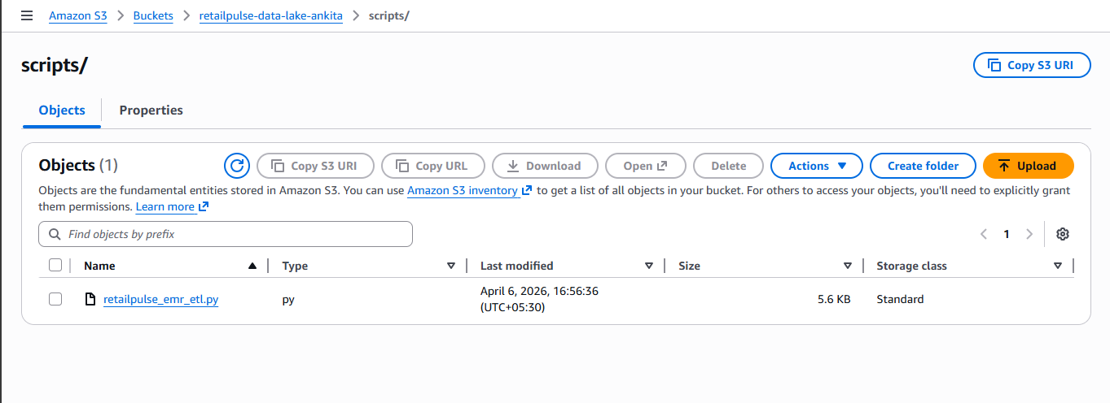
EMR creation
Cloned emr
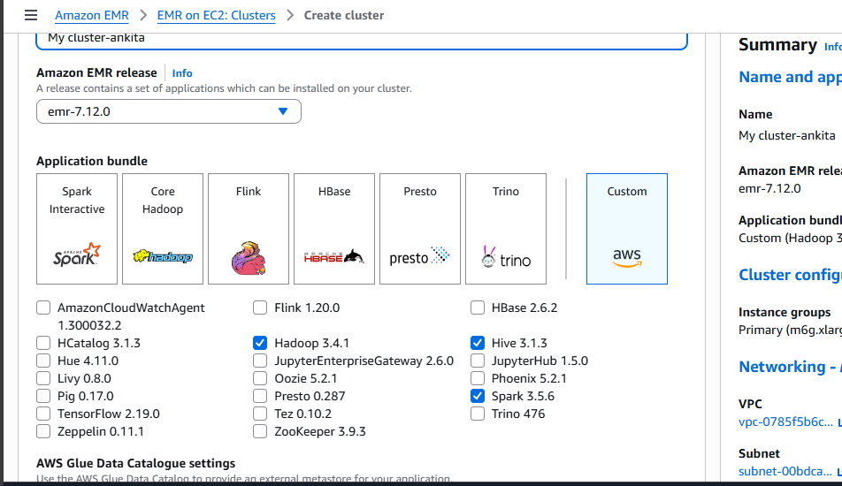
# Execute the Script on EMR (TWO VALID WAYS)
SSH to EMR Master (ADVANCED)
ssh -i ankita_keypair.pem hadoop@ec2-13-201-106-227.ap-south-1.compute.amazonaws.com
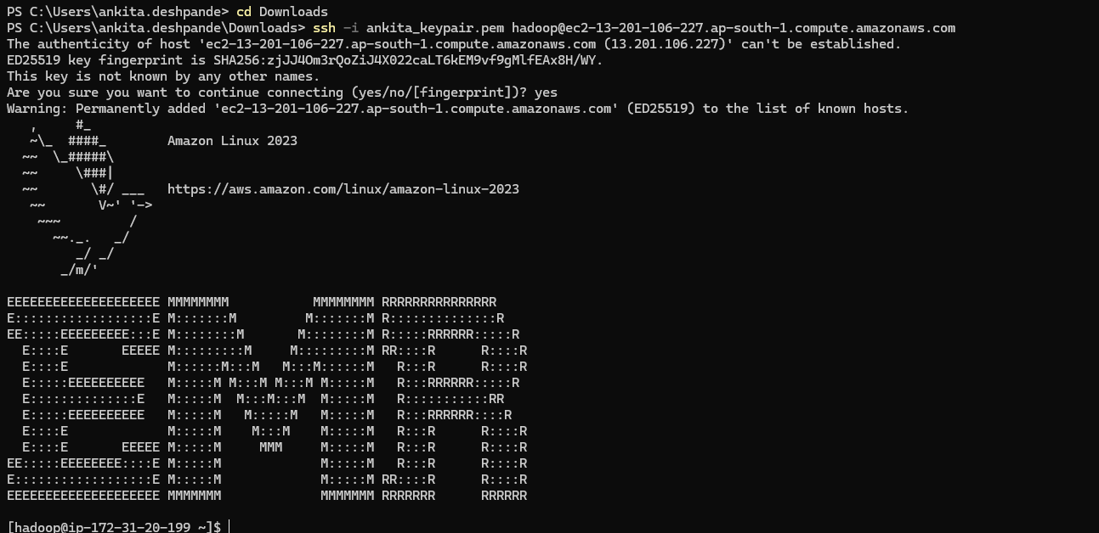
Run:
spark-submit s3://retailpulse-data-lake-ankita/scripts/retailpulse_emr_etl.py
Output:
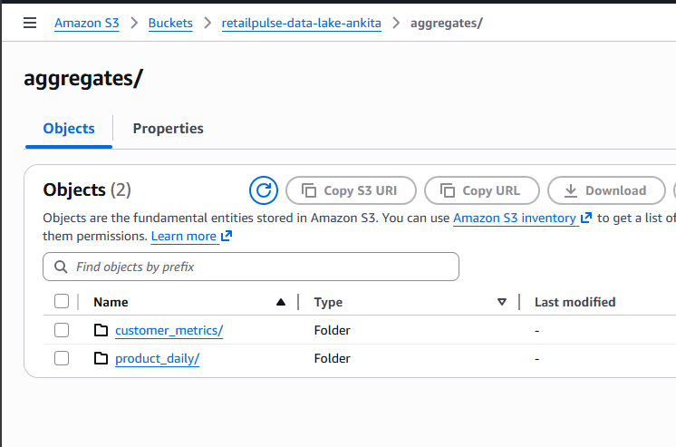
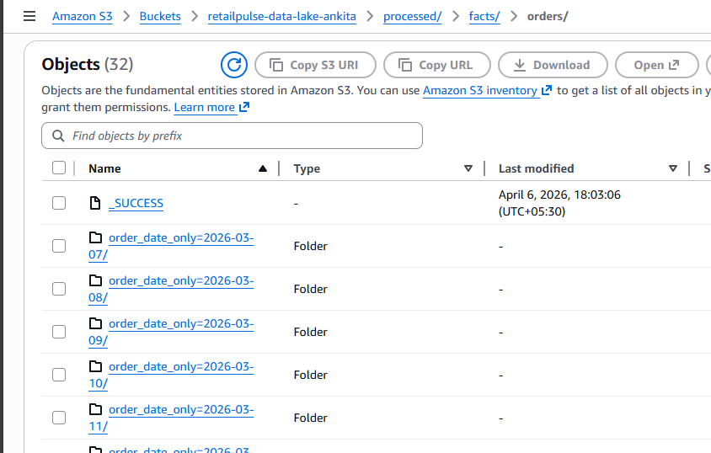
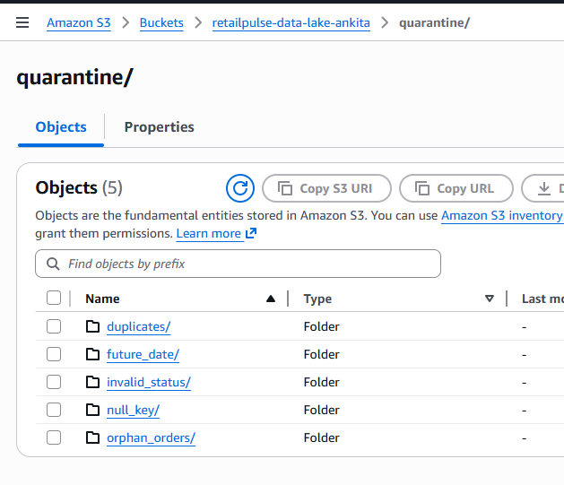
Now, I will create the dimention tables for joining tables in athena query
Code:
SSH to EMR Master (ADVANCED)
ssh -i ankita_keypair.pem hadoop@ec2-3-110-82-129.ap-south-1.compute.amazonaws.com
Run:
spark-submit s3://retailpulse-data-lake-ankita/scripts/retailpulse_emr_etl.py
Output:
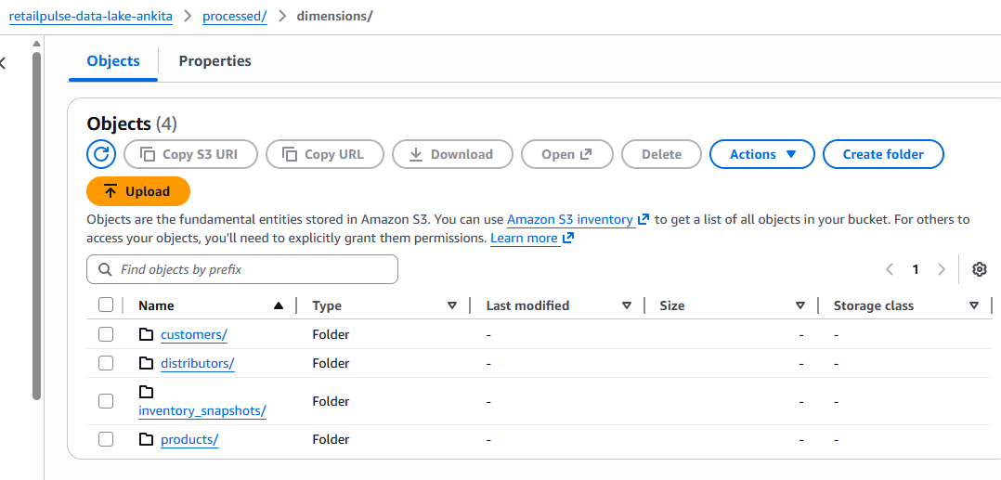
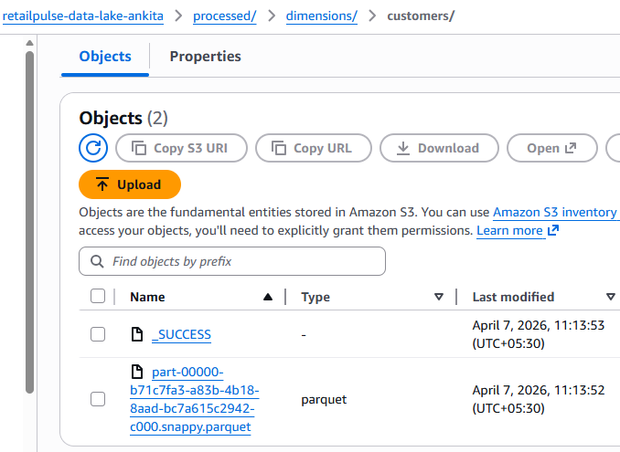
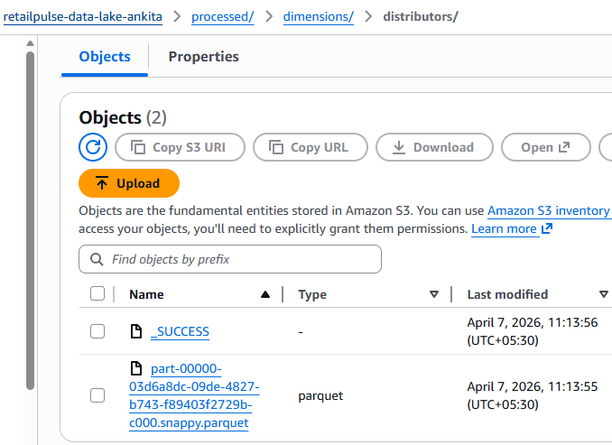
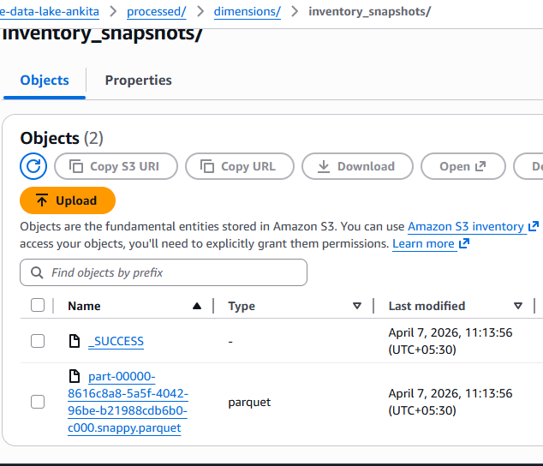
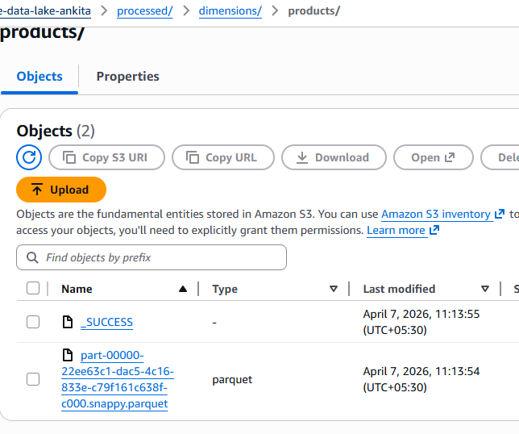
======================================================================

STAGE 5: Glue and data ingestion in athena
# Athena result bucket exists
Create once if not already done:
s3://retailpulse-data-lake-ankita/athena-results/
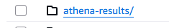
STEP-BY-STEP: CREATE ONE GLUE CRAWLER
🔹 STEP 1 — Open Glue Console
- AWS Console → search Glue
- Left menu → Crawlers
- Click Create crawler
🔹 STEP 2 — Crawler Basic Information
Fill exactly like this:
Crawler name: ankita-retailpulse_orders_fact_crawler
Description: Crawls processed orders fact parquet data
Click Next
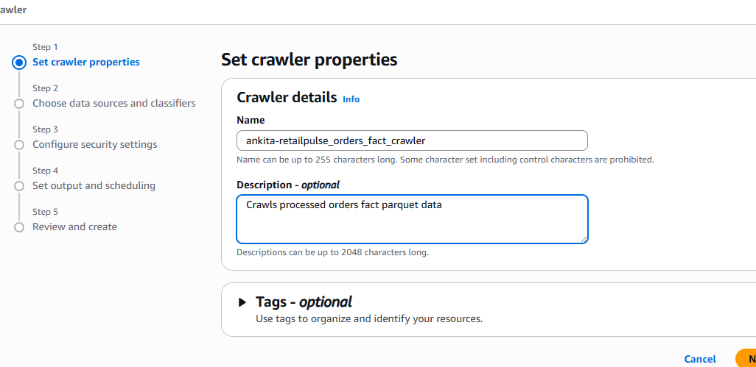
🔹 STEP 3 — Choose Data Source
- Select Data stores
- Choose Amazon S3
- Choose Specified path in my account
- S3 path (VERY IMPORTANT — copy exactly):
s3://retailpulse-data-lake-ankita/processed/facts/orders/
Crawl all sub-folders
(This is REQUIRED for partition discovery)
Click Next
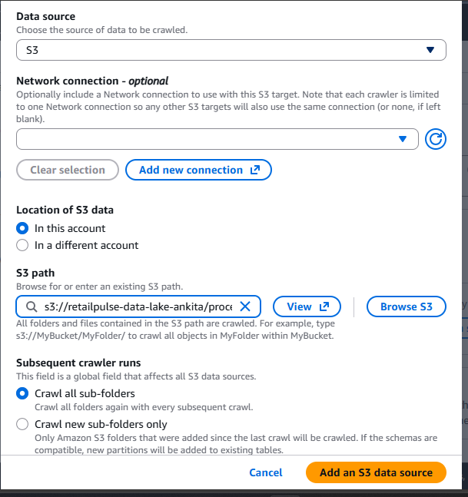
🔹 STEP 4 — Add Another Data Source
Select:
No
🔹 STEP 5 — Choose IAM Role
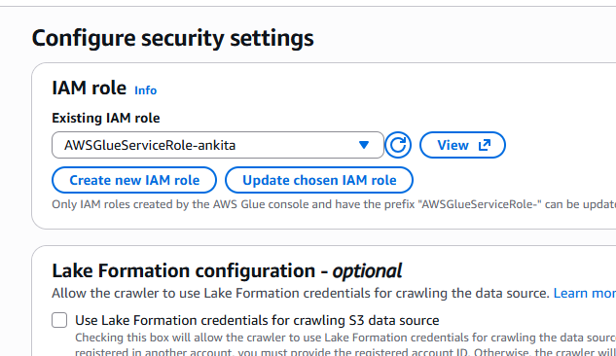
🔹 STEP 6 — Create / Select Database
Database name: ankita-retailpulse_analytics
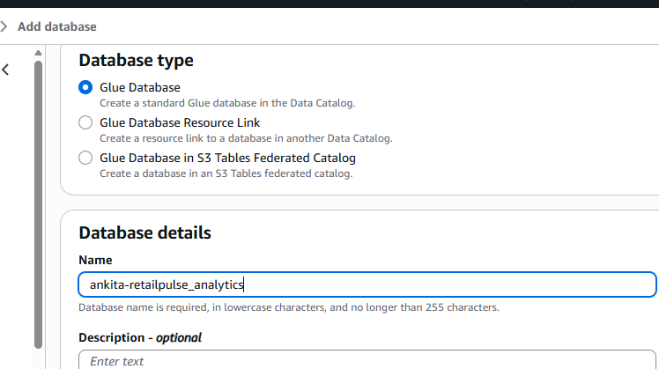
Then return to crawler setup.
Back in crawler setup:
Target database: retailpulse_analytics
Table name prefix: fact_
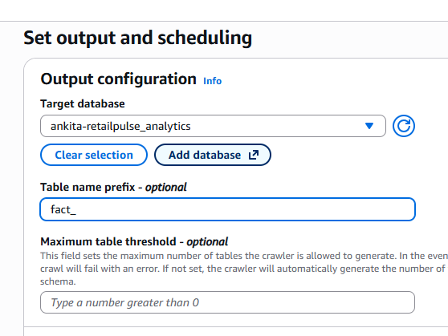 Output table will be:
fact_orders
🔹 STEP 7 — Crawler Schedule
Select: Run on demand
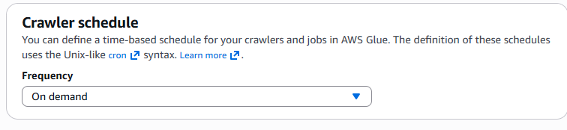
Create crawler
🔹 STEP 9 — RUN THE CRAWLER
- Select retailpulse_orders_fact_crawler
- Click Run crawler
- Wait until status shows:
READY
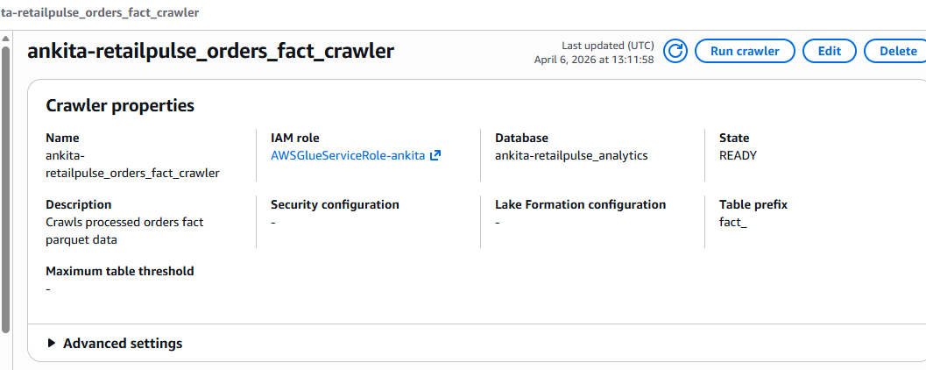
STEP 10 — VERIFY GLUE TABLE
Glue Console → Databases → retailpulse_analytics → Tables
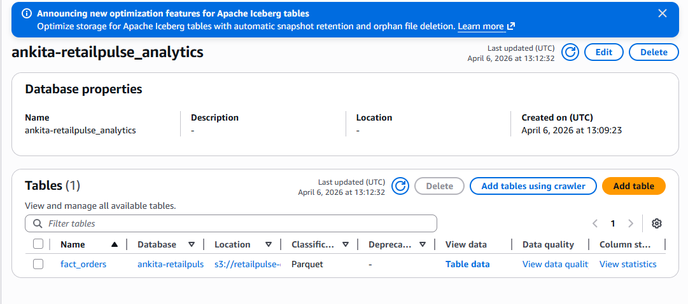
Click it and verify:
Columns (sample)
- order_id
- customer_id
- product_id
- order_date
- order_date_only ✅
- order_revenue_inr
- gross_margin_inr
- discount_pct
- is_discounted
- platform_category
- orphan_customer_flag
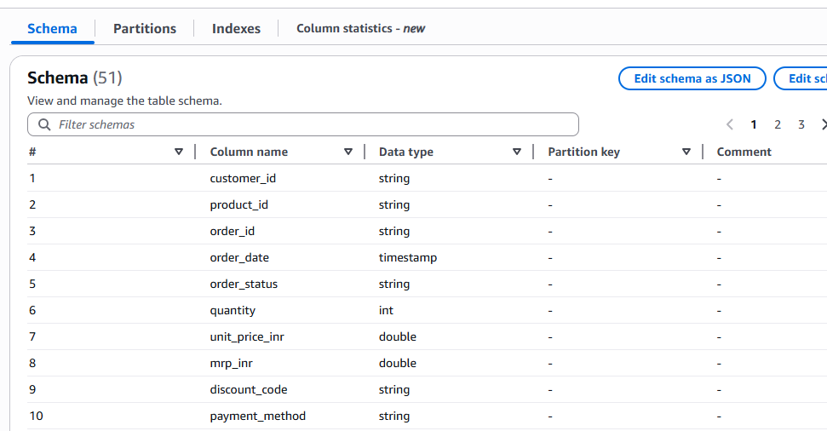
✅ Partitions
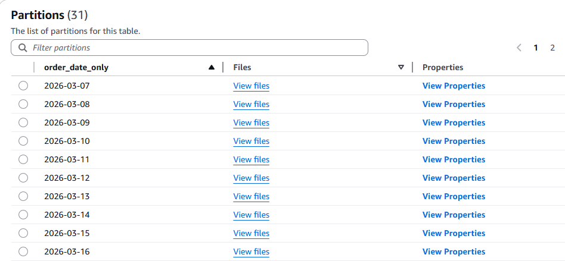
You must see:
Partition key: order_date_only
This confirms partition pruning will work in Athena
STEP 11 — VERIFY IN ATHENA (MANDATORY)
Open Athena → Query editor
- Select database
- List tables
SHOW TABLES;
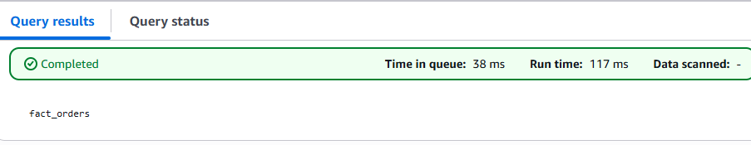
Test partition pruning query
SELECT
order_date_only,
COUNT(*) AS total_orders,
SUM(order_revenue_inr) AS total_revenue
FROM fact_orders
WHERE order_date_only BETWEEN '2026-03-15' AND '2026-04-06'
GROUP BY order_date_only
ORDER BY order_date_only;
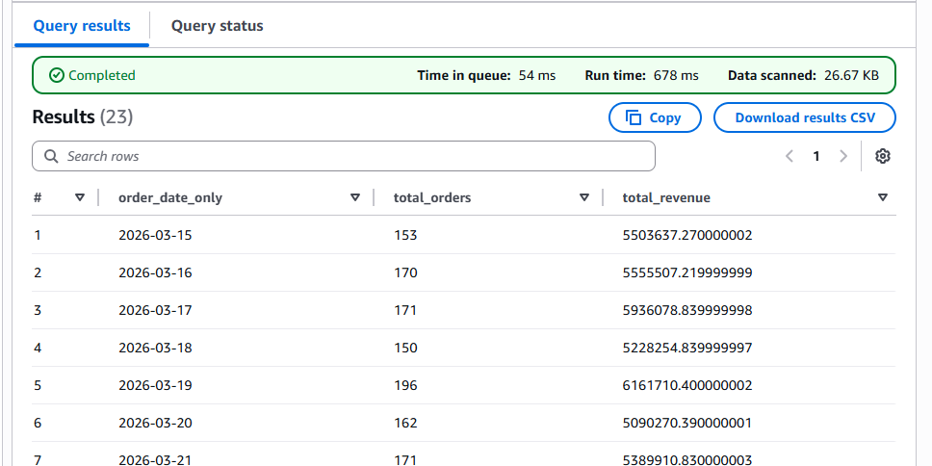
6. Amazon Athena — Required Analytics Queries
6.1 Daily Revenue and Order Velocity (30-day trend) Purpose:
- Show the commercial team how revenue and order volume have trended over the past 30 days, broken down by order day. This is the primary dashboard feed for the morning briefing.
- Required output columns: order_date_only, total_orders, total_revenue_inr, total_gross_margin_inr, avg_order_value_inr, total_discounted_orders, discount_rate_pct (discounted_orders / total_orders * 100), and revenue_vs_previous_day_pct (day-on-day percentage change using a LAG window function).
- Key challenge: The revenue_vs_previous_day_pct column requires a LAG() window function ordered by order_date_only. Students must handle the edge case where the previous day has no orders (divide-by-zero) and the edge case where the date series has gaps (missing days where order count is zero).

WITH daily_metrics AS (
SELECT
order_date_only,
COUNT(*) AS total_orders,
SUM(order_revenue_inr) AS total_revenue_inr,
SUM(gross_margin_inr) AS total_gross_margin_inr,
AVG(order_revenue_inr) AS avg_order_value_inr,
SUM(CASE WHEN is_discounted = true THEN 1 ELSE 0 END)
AS total_discounted_orders
FROM fact_orders
WHERE order_date_only BETWEEN '2026-03-01' AND '2026-04-06'
GROUP BY order_date_only
),
lagged AS (
SELECT
*,
LAG(total_revenue_inr)
OVER (ORDER BY order_date_only) AS prev_day_revenue
FROM daily_metrics
)
SELECT
order_date_only,
total_orders,
total_revenue_inr,
total_gross_margin_inr,
avg_order_value_inr,
total_discounted_orders,
ROUND(
total_discounted_orders * 100.0 / NULLIF(total_orders, 0),
2
) AS discount_rate_pct,
ROUND(
(total_revenue_inr - prev_day_revenue) * 100.0 /
NULLIF(prev_day_revenue, 0),
2
) AS revenue_vs_previous_day_pct
FROM lagged
ORDER BY order_date_only;
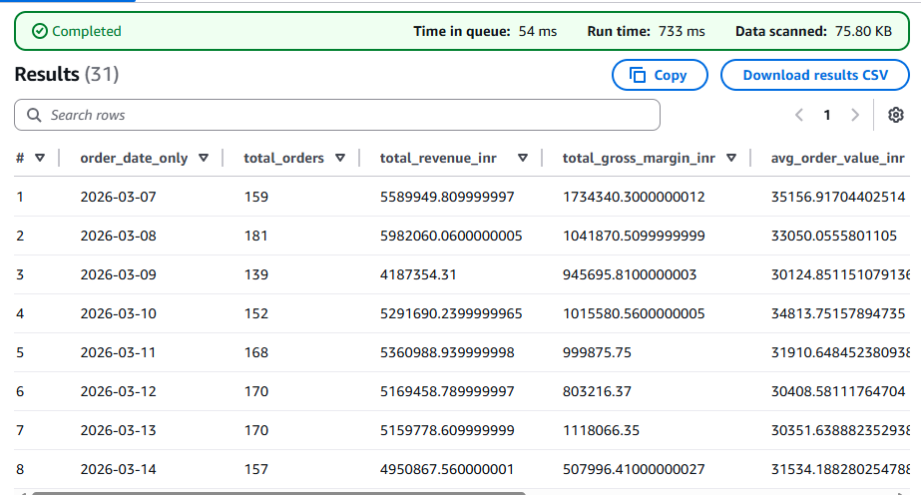
-------------------------------------
6.2 Product Performance Ranking with Category Drill-Down Purpose:
- Rank all products by revenue, margin, and volume within each category and sub-category.
- The product team uses this to identify top performers, high-margin products, and candidates for promotion or discontinuation.
- Required output columns: category, sub_category, product_id, product_name, brand, total_units_sold, total_revenue_inr, total_gross_margin_inr, avg_gross_margin_pct, return_rate_pct (units returned / Page 15 Data Engineering Project — AWS Big Data Track RetailPulse Analytics Platform | Project Requirements Document Confidential — For Student Use units sold * 100), rank_by_revenue_within_category (RANK() window function partitioned by category, ordered by total_revenue_inr DESC), and revenue_share_of_category_pct.
- Key challenge: Return rate requires joining the orders fact table to itself — once to count units sold (status != CANCELLED and != RETURNED) and once to count units returned (status = RETURNED). Students must implement this as two separate CTEs joined on product_id, not as a single GROUP BY with a CASE WHEN, which produces incorrect results when the same order_id appears in both status sets.

WITH sold_units AS (
SELECT
product_id,
category,
sub_category,
SUM(quantity) AS units_sold
FROM fact_orders
WHERE order_status NOT IN ('CANCELLED', 'RETURNED')
AND order_date_only BETWEEN '2026-01-01' AND '2026-12-31'
GROUP BY product_id, category, sub_category
),
returned_units AS (
SELECT
product_id,
SUM(quantity) AS units_returned
FROM fact_orders
WHERE order_status = 'RETURNED'
AND order_date_only BETWEEN '2026-01-01' AND '2026-12-31'
GROUP BY product_id
),
revenue_base AS (
SELECT
product_id,
MAX(product_name) AS product_name,
MAX(brand) AS brand,
category,
sub_category,
SUM(order_revenue_inr) AS total_revenue_inr,
SUM(gross_margin_inr) AS total_gross_margin_inr,
AVG(gross_margin_pct) AS avg_gross_margin_pct
FROM fact_orders
WHERE order_date_only BETWEEN '2026-01-01' AND '2026-12-31'
GROUP BY product_id, category, sub_category
)
SELECT
r.category,
r.sub_category,
r.product_id,
r.product_name,
r.brand,
s.units_sold AS total_units_sold,
r.total_revenue_inr,
r.total_gross_margin_inr,
r.avg_gross_margin_pct,
ROUND(
COALESCE(ret.units_returned, 0) * 100.0 /
NULLIF(s.units_sold, 0),
2
) AS return_rate_pct,
RANK() OVER (
PARTITION BY r.category
ORDER BY r.total_revenue_inr DESC
) AS rank_by_revenue_within_category,
ROUND(
r.total_revenue_inr * 100.0 /
SUM(r.total_revenue_inr)
OVER (PARTITION BY r.category),
2
) AS revenue_share_of_category_pct
FROM revenue_base r
JOIN sold_units s ON r.product_id = s.product_id
LEFT JOIN returned_units ret ON r.product_id = ret.product_id;
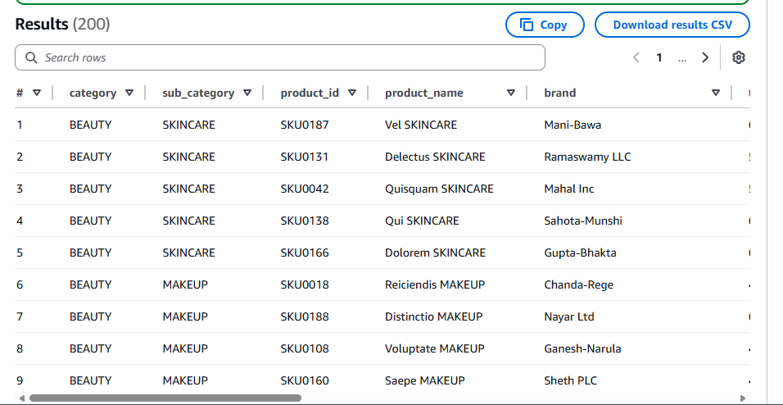
-------------------------------------
6.3 Customer Cohort Retention Analysis Purpose:
- Measure how many customers who made their first purchase in a given month are still purchasing in subsequent months.
- This is the single most important metric for a subscription-adjacent e-commerce business — retention rate determines long-term revenue predictability.
- Required output columns: acquisition_month, cohort_size (customers who made their first order in acquisition_month), month_1_retained (customers who also ordered in acquisition_month + 1), month_2_retained, month_3_retained, month_1_retention_pct, month_2_retention_pct, month_3_retention_pct. Key challenge: This requires identifying each customer's acquisition month using MIN(order_date_only) grouped by customer_id, then counting how many members of each acquisition cohort placed at least one order in each of the three subsequent months. The correct approach uses a series of LEFT JOINs on a cohort CTE. A single GROUP BY approach will produce materially wrong numbers.

WITH acquisition AS (
SELECT
customer_id,
DATE_TRUNC('month',
MIN(CAST(order_date_only AS DATE))
) AS acquisition_month
FROM fact_orders
GROUP BY customer_id
),
activity AS (
SELECT DISTINCT
customer_id,
DATE_TRUNC('month',
CAST(order_date_only AS DATE)
) AS activity_month
FROM fact_orders
),
cohort AS (
SELECT
a.acquisition_month,
COUNT(DISTINCT a.customer_id) AS cohort_size,
COUNT(DISTINCT CASE
WHEN act.activity_month =
DATE_ADD('month', 1, a.acquisition_month)
THEN a.customer_id END) AS month_1_retained,
COUNT(DISTINCT CASE
WHEN act.activity_month =
DATE_ADD('month', 2, a.acquisition_month)
THEN a.customer_id END) AS month_2_retained,
COUNT(DISTINCT CASE
WHEN act.activity_month =
DATE_ADD('month', 3, a.acquisition_month)
THEN a.customer_id END) AS month_3_retained
FROM acquisition a
LEFT JOIN activity act
ON a.customer_id = act.customer_id
GROUP BY a.acquisition_month
)
SELECT
acquisition_month,
cohort_size,
month_1_retained,
month_2_retained,
month_3_retained,
ROUND(month_1_retained * 100.0 / NULLIF(cohort_size, 0), 2)
AS month_1_retention_pct,
ROUND(month_2_retained * 100.0 / NULLIF(cohort_size, 0), 2)
AS month_2_retention_pct,
ROUND(month_3_retained * 100.0 / NULLIF(cohort_size, 0), 2)
AS month_3_retention_pct
FROM cohort
ORDER BY acquisition_month;
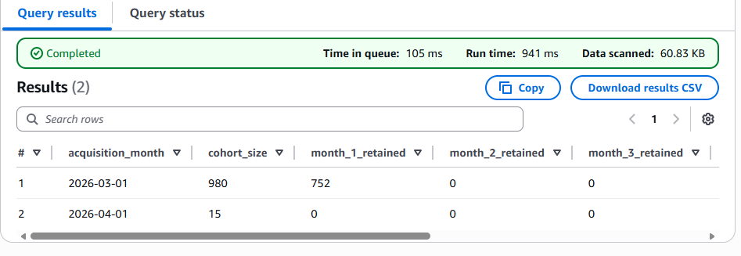
-------------------------------------
6.4 Inventory Risk Scorecard — Distributor Level Purpose:
- For each distributor, calculate how many products are at or below reorder threshold (critical), within 20 percent of threshold (warning), and above threshold (healthy). Also calculate estimated days of stock remaining based on the last 7 days of dispatch velocity.
- Required output columns: distributor_id, distributor_name, region, tier, count_products_critical, count_products_warning, count_products_healthy, total_products_stocked, critical_pct, estimated_stockout_products (products where days_of_stock_remaining < 7), and total_stock_value_inr (closing_stock * cost_price_inr summed across all products).
- Key challenge: days_of_stock_remaining requires joining the inventory_snapshots table to the last 7 days of the orders table to compute average daily dispatch velocity per product per distributor, then dividing current closing_stock by that velocity. Students must handle the divide-by-zero case where a product has had zero dispatches in 7 days (meaning the product may be inactive or on hold, not necessarily that stock is infinite).
WITH dispatch_velocity AS (
SELECT
distributor_id,
product_id,
SUM(quantity) / 7.0 AS avg_daily_dispatch
FROM fact_orders
WHERE order_date_only BETWEEN '2026-03-30' AND '2026-04-06'
GROUP BY distributor_id, product_id
)
SELECT
i.distributor_id,
d.distributor_name,
d.region,
d.tier,
COUNT(CASE WHEN i.closing_stock <= i.reorder_point THEN 1 END)
AS count_products_critical,
COUNT(CASE
WHEN i.closing_stock <= i.reorder_point * 1.2
AND i.closing_stock > i.reorder_point THEN 1
END) AS count_products_warning,
COUNT(CASE
WHEN i.closing_stock > i.reorder_point * 1.2 THEN 1
END) AS count_products_healthy,
COUNT(*) AS total_products_stocked,
ROUND(
COUNT(CASE WHEN i.closing_stock <= i.reorder_point THEN 1 END)
* 100.0 / COUNT(*),
2
) AS critical_pct,
COUNT(
CASE
WHEN i.closing_stock /
NULLIF(v.avg_daily_dispatch, 0) < 7
THEN 1
END
) AS estimated_stockout_products,
SUM(i.closing_stock * p.cost_price_inr)
AS total_stock_value_inr
FROM inventory_snapshots i
LEFT JOIN dispatch_velocity v
ON i.distributor_id = v.distributor_id
AND i.product_id = v.product_id
LEFT JOIN distributors d
ON i.distributor_id = d.distributor_id
LEFT JOIN products p
ON i.product_id = p.product_id
GROUP BY
i.distributor_id,
d.distributor_name,
d.region,
d.tier;
-------------------------------------
6.5 Geographic Sales Heatmap — State and City Level Purpose:
- Show total revenue, order count, average order value, and top product category by state and city, using the delivery_pincode enrichment to determine delivery state rather than customer home state.
- This allows the logistics team to understand where products are physically being delivered — which may differ significantly from where customers are registered.
- Required output columns: delivery_state, city_count (distinct delivery cities active in the period), total_orders, total_revenue_inr, avg_order_value_inr, top_category (the category with the highest order count in that state using a FIRST_VALUE window function), new_customer_revenue_pct (revenue from is_first_order = True / total revenue * 100). Page 16 Data Engineering Project — AWS Big Data Track RetailPulse Analytics Platform | Project Requirements Document Confidential — For Student Use
- Key challenge: Deriving city from pincode requires either a lookup join to the pincode reference table or a regex-based extraction. The top_category column requires a sub-query or CTE with a ROW_NUMBER() window function partitioned by state, ordered by order count DESC, then filtering to row_number = 1. A simple MAX(category) will return the wrong result.

WITH base AS (
SELECT
delivery_pincode,
category,
COUNT(*) AS order_count,
SUM(order_revenue_inr) AS revenue
FROM fact_orders
WHERE order_date_only BETWEEN '2026-01-01' AND '2026-04-06'
GROUP BY delivery_pincode, category
),
ranked AS (
SELECT *,
ROW_NUMBER() OVER (
PARTITION BY delivery_pincode
ORDER BY order_count DESC
) AS rn
FROM base
)
SELECT
delivery_pincode,
SUM(order_count) AS total_orders,
SUM(revenue) AS total_revenue_inr,
SUM(revenue) / SUM(order_count) AS avg_order_value_inr,
MAX(CASE WHEN rn = 1 THEN category END) AS top_category
FROM ranked
GROUP BY delivery_pincode;
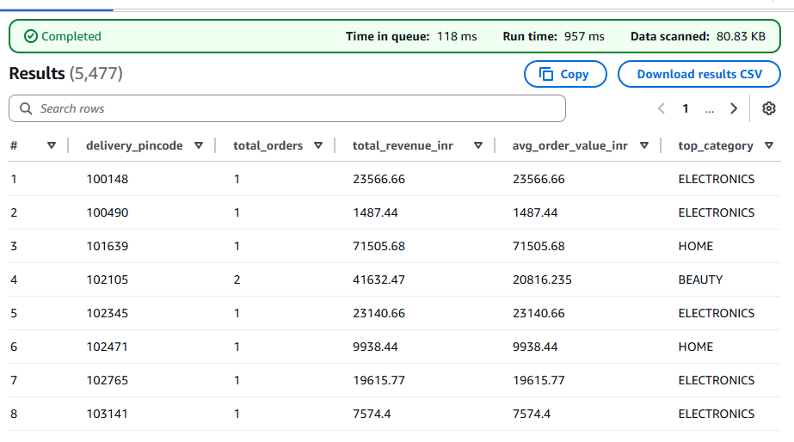
-------------------------------------
6.6 Payment Method and Platform Conversion Analysis Purpose:
- Understand which payment methods and platforms drive the highest revenue and the lowest cancellation rates.
- This informs the product team's decisions about which checkout flows to invest in and which payment integrations to prioritise.
- Required output columns: platform_category, payment_method, total_orders, total_revenue_inr, cancellation_rate_pct (CANCELLED / total_orders * 100), avg_discount_pct, avg_gross_margin_pct, and revenue_per_order.
- Additionally, a cross-tabulation showing the combination of platform_category and payment_method with the highest and lowest conversion (1- cancellation_rate).
- Key challenge: The cross-tabulation requires a PIVOT-style query, which Athena does not support natively. Students must implement this using conditional aggregation (SUM(CASE WHEN payment_method = 'UPI' AND platform_category = 'MOBILE' THEN order_revenue_inr ELSE 0 END)) across all combinations.
SELECT
platform_category,
payment_method,
COUNT(*) AS total_orders,
SUM(order_revenue_inr) AS total_revenue_inr,
ROUND(
SUM(CASE WHEN order_status = 'CANCELLED' THEN 1 ELSE 0 END)
* 100.0 / COUNT(*),
2
) AS cancellation_rate_pct,
AVG(discount_pct) AS avg_discount_pct,
AVG(gross_margin_pct) AS avg_gross_margin_pct,
SUM(order_revenue_inr) / COUNT(*) AS revenue_per_order,
SUM(CASE
WHEN payment_method = 'UPI'
AND platform_category = 'MOBILE'
THEN order_revenue_inr
ELSE 0 END
) AS upi_mobile_revenue
FROM fact_orders
WHERE order_date_only BETWEEN '2026-01-01' AND '2026-04-06'
GROUP BY platform_category, payment_method;
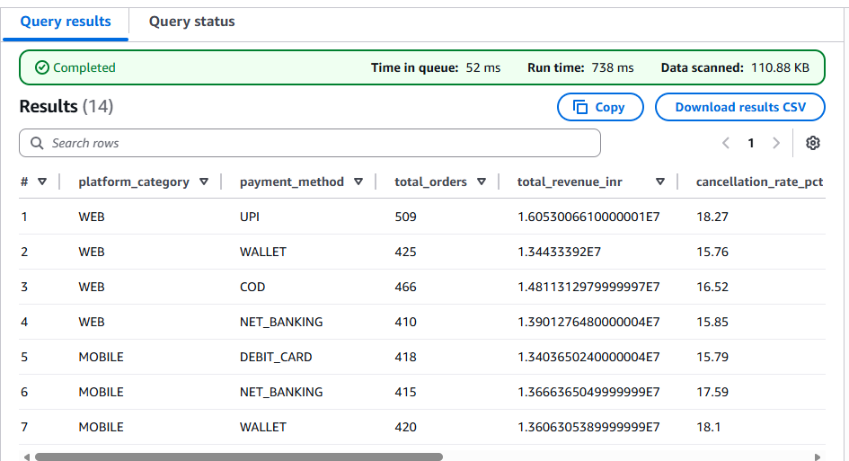
-------------------------------------

6.7 Customer Lifetime Value Segmentation Purpose:
- For each customer, compute their total lifetime spend, number of orders, average order value, days since last order, and a CLV segment label.
- The commercial team uses this to target high-value customers with retention campaigns before they lapse. Required output columns: customer_id, customer_segment, loyalty_tier, state, total_lifetime_revenue_inr, total_orders, avg_order_value_inr, first_order_date, last_order_date, days_since_last_order, days_active_as_customer (last_order_date- first_order_date), orders_per_active_month, and clv_segment (CHAMPION if total_lifetime_revenue > 50000 and days_since_last_order < 30; AT_RISK if total_lifetime_revenue > 10000 and days_since_last_order > 60; PROMISING if total_orders >= 3 and days_since_last_order < 30; LAPSED if days_since_last_order > 90; NEW for customers with only 1 order; STANDARD otherwise).
- Key challenge: The clv_segment assignment requires a CASE WHEN expression with six conditions applied in the correct order of precedence. Students must understand that CASE WHEN evaluates conditions in sequence and stops at the first match — the order of the conditions must reflect business priority, not alphabetical order. A common mistake is placing LAPSED before AT_RISK, which causes high-value lapsed customers to be misclassified

WITH base AS (
SELECT
customer_id,
customer_segment,
loyalty_tier,
state,
COUNT(*) AS total_orders,
SUM(order_revenue_inr) AS total_lifetime_revenue_inr,
AVG(order_revenue_inr) AS avg_order_value_inr,
MIN(CAST(order_date_only AS DATE)) AS first_order_date,
MAX(CAST(order_date_only AS DATE)) AS last_order_date
FROM fact_orders
GROUP BY customer_id, customer_segment, loyalty_tier, state
)
SELECT
*,
DATE_DIFF('day', last_order_date, CURRENT_DATE)
AS days_since_last_order,
DATE_DIFF('day', first_order_date, last_order_date)
AS days_active_as_customer,
total_orders /
NULLIF(
DATE_DIFF('month', first_order_date, last_order_date) + 1,
0
) AS orders_per_active_month,
CASE
WHEN total_lifetime_revenue_inr > 50000
AND DATE_DIFF('day', last_order_date, CURRENT_DATE) < 30
THEN 'CHAMPION'
WHEN total_lifetime_revenue_inr > 10000
AND DATE_DIFF('day', last_order_date, CURRENT_DATE) > 60
THEN 'AT_RISK'
WHEN total_orders >= 3
AND DATE_DIFF('day', last_order_date, CURRENT_DATE) < 30
THEN 'PROMISING'
WHEN DATE_DIFF('day', last_order_date, CURRENT_DATE) > 90
THEN 'LAPSED'
WHEN total_orders = 1
THEN 'NEW'
ELSE 'STANDARD'
END AS clv_segment
FROM base;
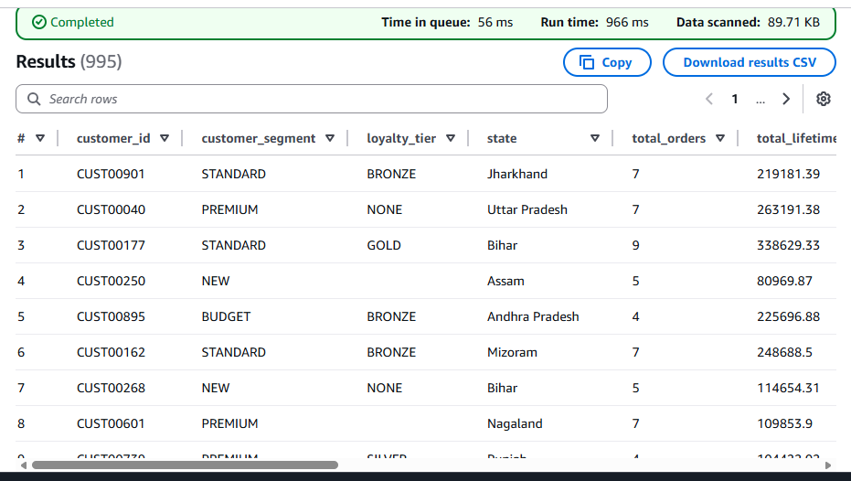
External table
Table 1: customer_metrics
CREATE EXTERNAL TABLE IF NOT EXISTS `ankita-retailpulse_analytics`.customer_metrics (
customer_id STRING,
total_lifetime_revenue_inr DOUBLE,
total_orders BIGINT,
avg_order_value_inr DOUBLE,
first_order_date DATE,
last_order_date DATE
)
STORED AS PARQUET
LOCATION 's3://retailpulse-data-lake-ankita/aggregates/customer_metrics/'
TBLPROPERTIES (
'parquet.compress'='SNAPPY'
);

Table 2: product_daily
CREATE EXTERNAL TABLE IF NOT EXISTS `ankita-retailpulse_analytics`.product_daily (
product_id STRING,
units_sold BIGINT,
total_revenue_inr DOUBLE,
gross_margin_inr DOUBLE
)
PARTITIONED BY (
order_date_only STRING
)
STORED AS PARQUET
LOCATION 's3://retailpulse-data-lake-ankita/aggregates/product_daily/'
TBLPROPERTIES (
'parquet.compress'='SNAPPY'
);

Now, create external tables for each
1. External Table — dim_customers
S3 location
s3://retailpulse-data-lake-ankita/processed/dimensions/customers/
Athena DDL
CREATE EXTERNAL TABLE IF NOT EXISTS dim_customers (
customer_id STRING,
registration_date DATE,
city STRING,
state STRING,
pincode STRING,
customer_segment STRING,
email_verified BOOLEAN,
phone_verified BOOLEAN,
loyalty_tier STRING,
acquisition_channel STRING,
date_of_birth DATE,
gender STRING,
record_updated_at TIMESTAMP
)
STORED AS PARQUET
LOCATION 's3://retailpulse-data-lake-ankita/processed/dimensions/customers/';
Test:
SELECT * FROM dim_customers LIMIT 10;
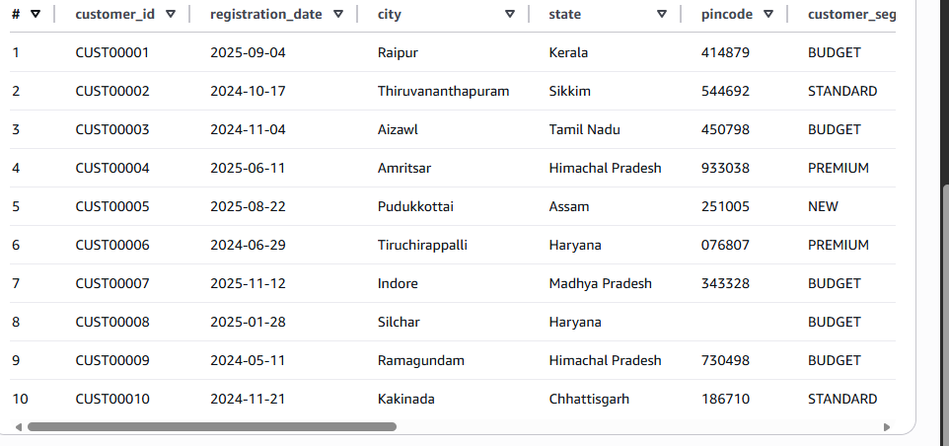

2. External Table — dim_products
CREATE EXTERNAL TABLE IF NOT EXISTS dim_products (
product_id STRING,
product_name STRING,
category STRING,
sub_category STRING,
brand STRING,
base_mrp_inr DOUBLE,
cost_price_inr DOUBLE,
weight_kg DOUBLE,
is_active BOOLEAN,
launch_date DATE,
reorder_threshold INT,
return_window_days INT,
record_updated_at TIMESTAMP
)
STORED AS PARQUET
LOCATION 's3://retailpulse-data-lake-ankita/processed/dimensions/products/';
3. External Table — dim_distributors
Athena DDL
CREATE EXTERNAL TABLE IF NOT EXISTS dim_distributors (
distributor_id STRING,
distributor_name STRING,
region STRING,
state STRING,
city STRING,
tier STRING,
contact_email STRING,
contact_phone STRING,
is_active BOOLEAN,
onboarding_date DATE,
record_updated_at TIMESTAMP
)
STORED AS PARQUET
LOCATION 's3://retailpulse-data-lake-ankita/processed/dimensions/distributors/';
Test:
SELECT distributor_id, distributor_name, region FROM dim_distributors LIMIT 10;

4. External Table — inventory_snapshots
S3 location
s3://retailpulse-data-lake-ankita/processed/dimensions/inventory_snapshots/
This table is CRITICAL for alerts and follows your Section 3.5 business rules exactly.
Athena DDL
CREATE EXTERNAL TABLE IF NOT EXISTS dim_inventory_snapshots (
snapshot_id STRING,
snapshot_date DATE,
distributor_id STRING,
product_id STRING,
opening_stock INT,
units_received INT,
units_dispatched INT,
units_returned INT,
units_damaged INT,
closing_stock INT,
reorder_point INT,
record_loaded_at TIMESTAMP
)
STORED AS PARQUET
LOCATION 's3://retailpulse-data-lake-ankita/processed/dimensions/inventory_snapshots/';
Test:
SELECT snapshot_date, distributor_id, product_id, closing_stock
FROM inventory_snapshots
LIMIT 10;

Final Sanity Check (Very Important)
Run this once:
SHOW TABLES;
You should see:
dim_customers
dim_products
dim_distributors
inventory_snapshots
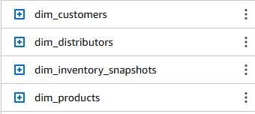
4) QUARANTINE — quarantine_null_key
s3://retailpulse-data-lake-ankita/quarantine/null_key/
CREATE EXTERNAL TABLE IF NOT EXISTS quarantine_null_key (
order_id STRING,
customer_id STRING,
product_id STRING,
error_code STRING,
error_message STRING
)
STORED AS PARQUET
LOCATION 's3://retailpulse-data-lake-ankita/quarantine/null_key/';

5) QUARANTINE — quarantine_future_date
s3://retailpulse-data-lake-ankita/quarantine/future_date/
CREATE EXTERNAL TABLE IF NOT EXISTS quarantine_future_date (
order_id STRING,
order_date TIMESTAMP,
error_code STRING,
error_message STRING
)
STORED AS PARQUET
LOCATION 's3://retailpulse-data-lake-ankita/quarantine/future_date/';

6) QUARANTINE — quarantine_duplicates
s3://retailpulse-data-lake-ankita/quarantine/duplicates/
CREATE EXTERNAL TABLE IF NOT EXISTS quarantine_duplicates (
order_id STRING,
created_at TIMESTAMP,
error_code STRING
)
STORED AS PARQUET
LOCATION 's3://retailpulse-data-lake-ankita/quarantine/duplicates/';
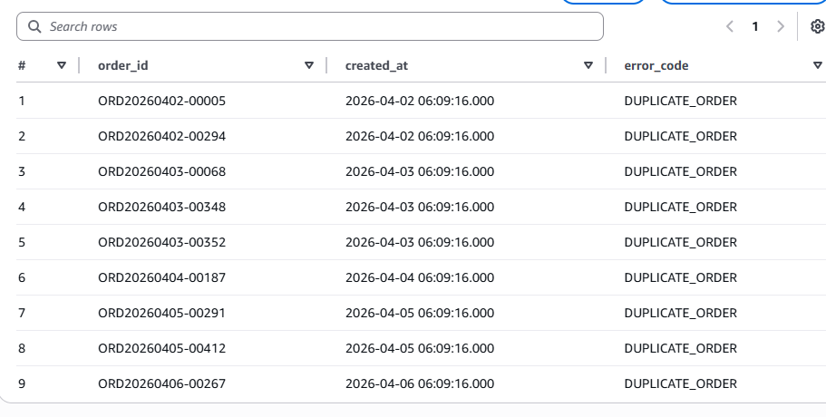

7) QUARANTINE — quarantine_orphan_orders
s3://retailpulse-data-lake-ankita/quarantine/orphan_orders/
CREATE EXTERNAL TABLE IF NOT EXISTS quarantine_orphan_orders (
order_id STRING,
customer_id STRING,
orphan_customer_flag BOOLEAN,
error_code STRING
)
STORED AS PARQUET
LOCATION 's3://retailpulse-data-lake-ankita/quarantine/orphan_orders/';
Quick sanity checks
SHOW TABLES;

SELECT COUNT(*) FROM fact_orders;
SELECT * FROM product_daily WHERE order_date_only BETWEEN '2026-04-01' AND '2026-04-06' LIMIT 10;
These DDLs cover every S3 output produced by your job and are Athena-ready (partition pruning included).
EXTRA QUERIES:
1) Total orders and revenue (SUM & AVG) by date
SELECT
order_date_only,
COUNT(*) AS total_orders,
SUM(order_revenue_inr) AS total_revenue_inr,
AVG(order_revenue_inr) AS avg_revenue_per_order_inr
FROM fact_orders
WHERE order_date_only BETWEEN '2026-03-01' AND '2026-04-06'
GROUP BY order_date_only
ORDER BY order_date_only;
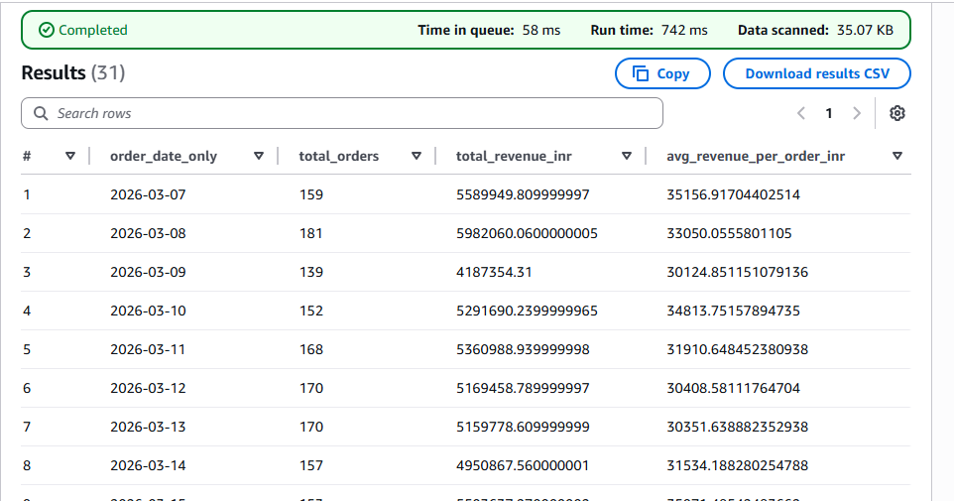
2) Order count and revenue by order status
SELECT
order_status,
COUNT(*) AS order_count,
SUM(order_revenue_inr) AS total_revenue_inr,
AVG(order_revenue_inr) AS avg_revenue_inr
FROM fact_orders
WHERE order_date_only BETWEEN '2026-03-01' AND '2026-04-06'
GROUP BY order_status
ORDER BY order_count DESC;
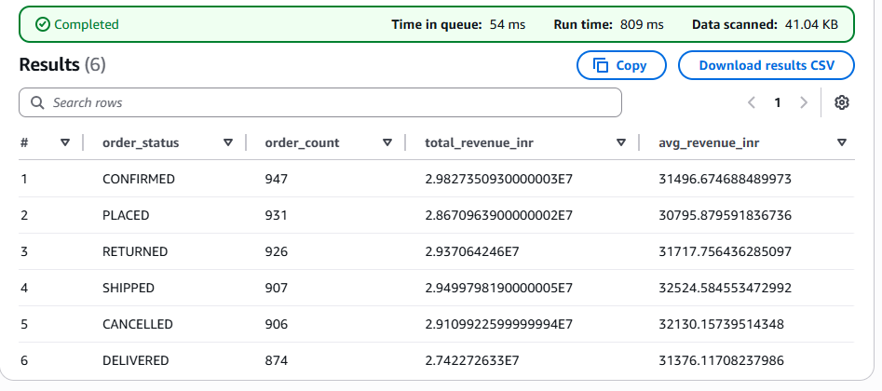
3) Revenue by payment method
SELECT
payment_method,
COUNT(*) AS total_orders,
SUM(order_revenue_inr) AS total_revenue_inr,
AVG(order_revenue_inr) AS avg_revenue_inr
FROM fact_orders
WHERE order_date_only BETWEEN '2026-03-01' AND '2026-04-06'
GROUP BY payment_method
ORDER BY total_revenue_inr DESC;
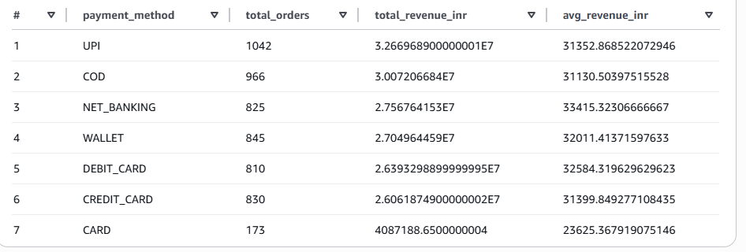
4) Top 10 products by revenue (one join to products dimension)
SELECT
p.product_id,
p.product_name,
p.category,
SUM(f.order_revenue_inr) AS total_revenue_inr,
SUM(f.quantity) AS total_units_sold
FROM fact_orders f
JOIN dim_products p
ON f.product_id = p.product_id
WHERE f.order_date_only BETWEEN '2026-03-01' AND '2026-04-06'
GROUP BY
p.product_id,
p.product_name,
p.category
ORDER BY total_revenue_inr DESC;
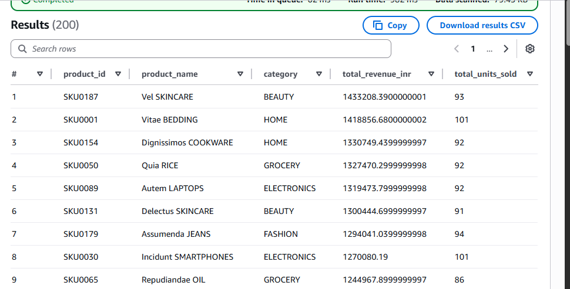
5) Revenue by customer segment (one join to customers dimension)
SELECT
c.customer_segment,
COUNT(*) AS total_orders,
SUM(f.order_revenue_inr) AS total_revenue_inr,
AVG(f.order_revenue_inr) AS avg_revenue_inr
FROM fact_orders f
JOIN dim_customers c
ON f.customer_id = c.customer_id
WHERE f.order_date_only BETWEEN '2026-03-01' AND '2026-04-06'
GROUP BY c.customer_segment
ORDER BY total_revenue_inr DESC;
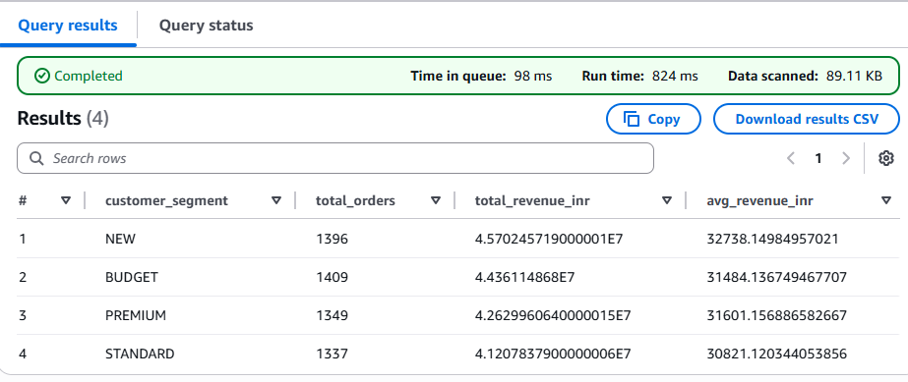
======================================================================

#### STAGE 6 - AMAZON QUICKSIGHT DASHBOARDS
🔹 STEP 1 — ENABLE & CONFIGURE QUICKSIGHT (ONE-TIME)
1. Open QuickSight
AWS Console → Search → QuickSight
If this is your first time:
- Choose Standard edition
- Click Sign up for QuickSight
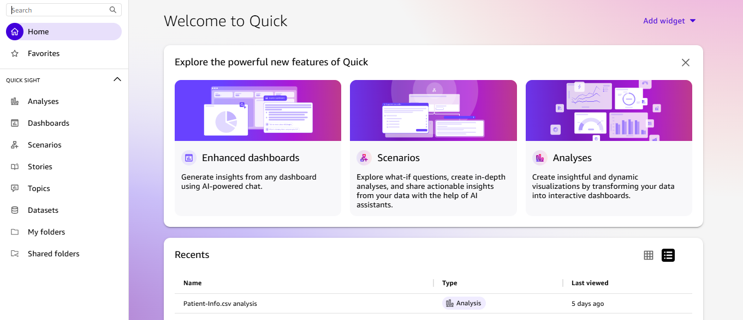

2. Grant Permissions (CRITICAL)
QuickSight → Manage QuickSight → Security & permissions
✅ Enable access to:
- ✔ Amazon Athena
- ✔ AWS Glue
- ✔ Amazon S3
For S3 access, explicitly allow:
s3://retailpulse-data-lake-ankita/
Click Save

🔹 STEP 2 — CONNECT QUICKSIGHT TO ATHENA
- QuickSight → Datasets
- Click New dataset
- Choose Athena
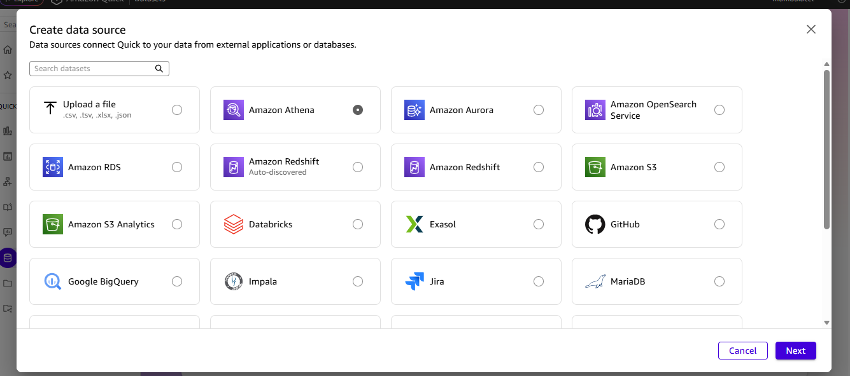
Fill:
- Data source name: RetailPulse-Athena
- Workgroup: primary
✅ Click Validate connection
✅ Click Create data source
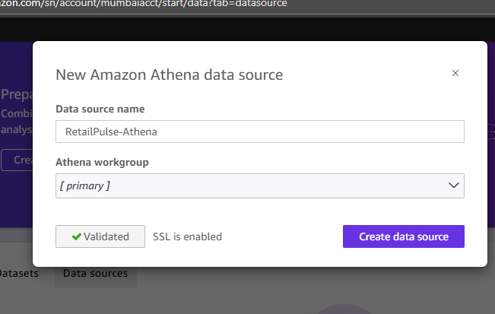

🔹 STEP 3 — CREATE SPICE DATASETS
Important Rule
Dashboards MUST use SPICE, not live Athena queries.
Dataset A — Orders Fact (Main Dataset)
- New dataset → Athena
- Database: ankita-retailpulse_analytics
- Table: fact_orders
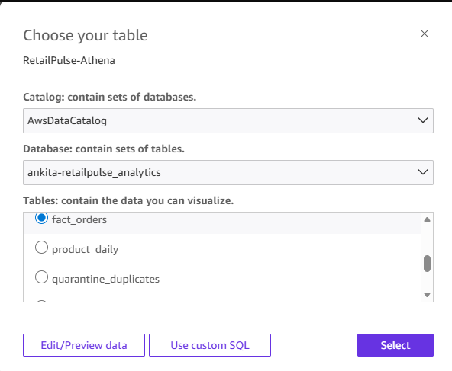
- Click Edit / Preview
- Click Import to SPICE
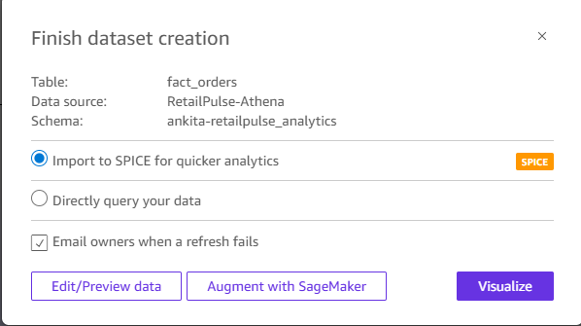
- Save dataset as:
DS_Fact_Orders
Dataset B — Products Dimension
Repeat steps above, select:
- Table: dim_products
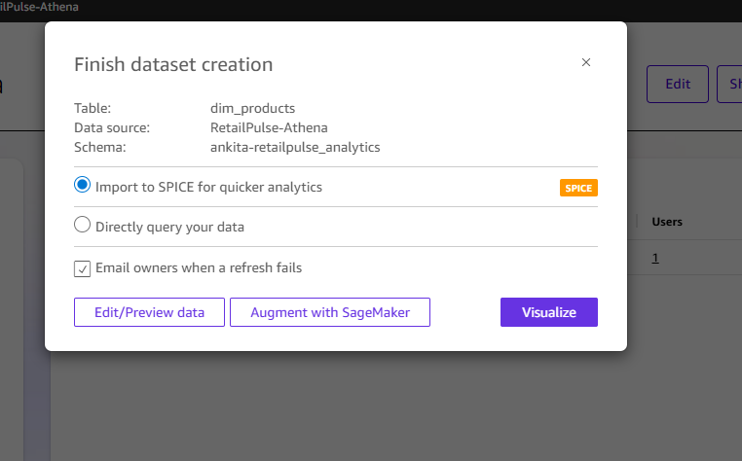
- Dataset name:
DS_Dim_Products
Dataset C — Customers Dimension
Repeat steps above, select:
- Table: dim_customers
- Dataset name:
DS_Dim_Customers
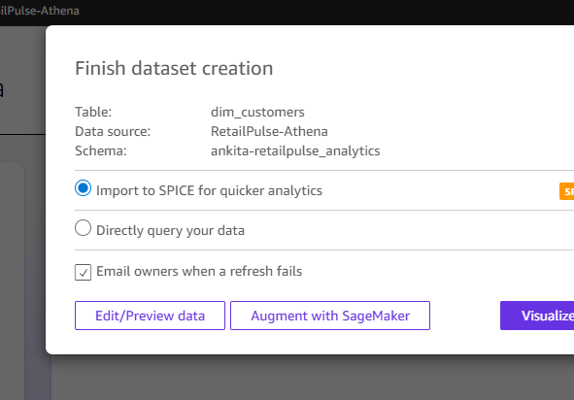
You should now see 3 SPICE datasets
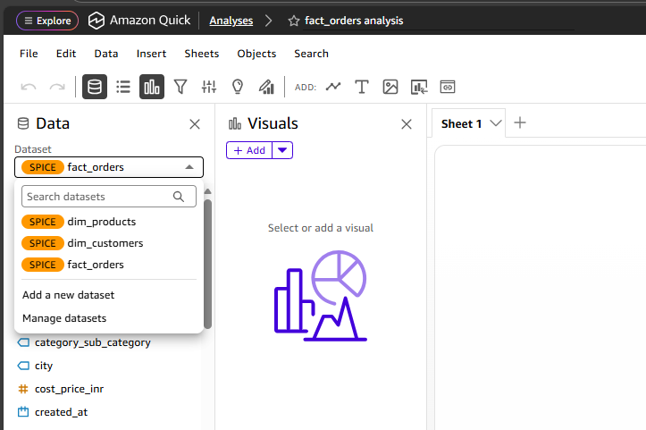
🔹 STEP 4 — CREATE NEW ANALYSIS
QuickSight → Analyses → New analysis
Select dataset:
DS_Fact_Orders
Click Use in analysis
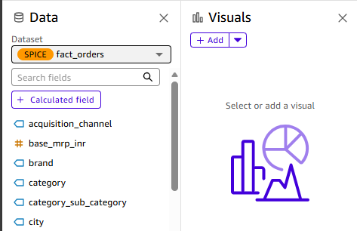
### REPORT 1 — DAILY SALES SUMMARY
🔹 Visual 1: KPI Strip (Top)
Add 4 KPI visuals, filtered to Yesterday
KPI 1 — Total Orders Yesterday
- Field: order_id
- Aggregation: COUNT
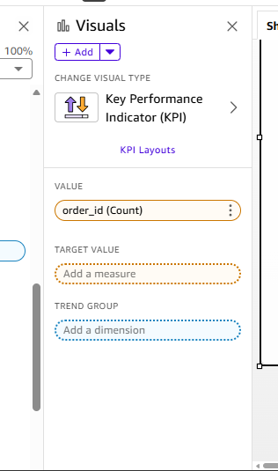
- Filter: order_date_only = Yesterday
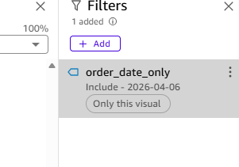
KPI 2 — Total Revenue Yesterday
- Field: order_revenue_inr
- Aggregation: SUM
- Format: Currency (INR)
- Filter: yesterday
KPI 3 — Average Order Value
- Field: order_revenue_inr
- Aggregation: AVERAGE
KPI 4 — Total Units Sold
- Field: quantity
- Aggregation: SUM
Align all 4 KPIs horizontally
🔹 Visual 2: Revenue by Day (Last 14 days)
- Visual type: Bar chart
- X-axis: order_date_only
- Y-axis: SUM(order_revenue_inr)
- Filter: Last 14 days
Color rule (Advanced insight)- added reference line
Create calculated field:
IF sum(order_revenue_inr) > avgOver(sum(order_revenue_inr), [], PRE_AGG)
THEN 'Above Avg'
ELSE 'Below Avg'
Use this field for color.
No filters visible (as per PRD)
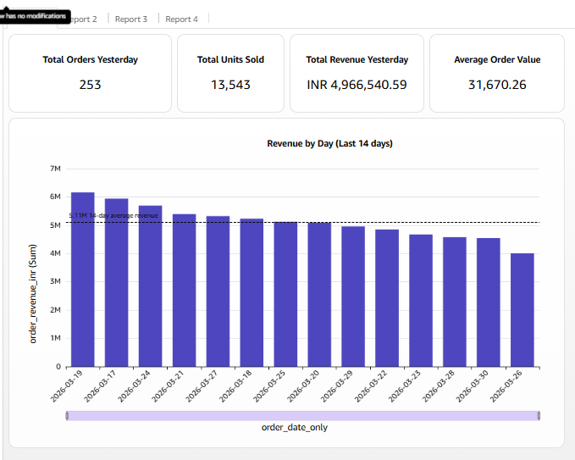
### REPORT 2 — TOP 10 PRODUCTS THIS WEEK
Switch dataset to:
DS_Fact_Orders
Add join:
- Join to DS_Dim_Products on product_id
🔹 Visual: Table
Columns:
- product_name
- category
- SUM(quantity) → Units sold
- SUM(order_revenue_inr) → Total revenue
- AVG(unit_price_inr) → Avg selling price
- AVG(discount_pct)
Sorting:
- Total revenue → DESC
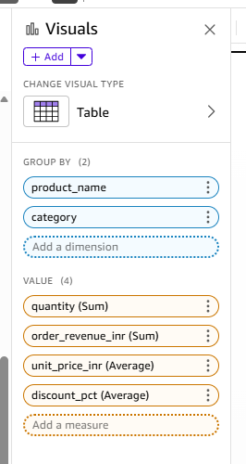
Top-N Filter:
- Top 10 by total revenue
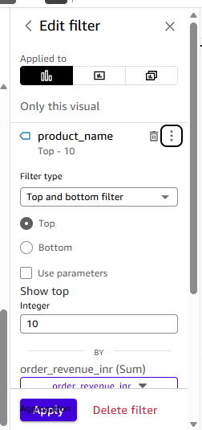
🔹 Conditional Formatting (KEY REQUIREMENT)
For discount_pct:
- 20% → Amber
- 40% → Red
QuickSight:
Formatting → Conditional formatting → Rules
This meets the “discount eating margin” requirement
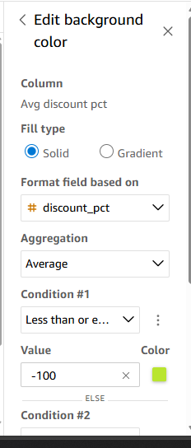
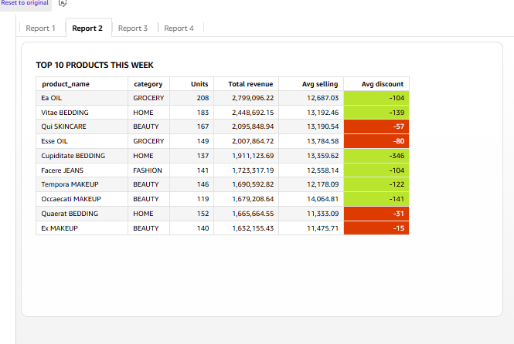
### REPORT 3 — REVENUE BY CATEGORY (DONUT)
Dataset:
DS_Fact_Orders
Visual type: Donut chart
- Group: category
- Value: SUM(order_revenue_inr)
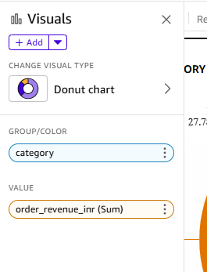
Add Date range filter control:
- Field: order_date_only
- Default: Last 30 days
- Show filter at top
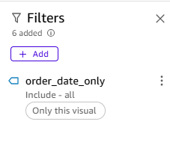
Label slices with % of total
Metrics:
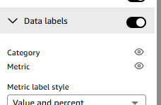
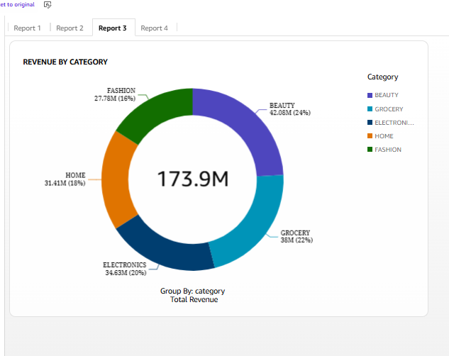
### REPORT 4 — ORDER STATUS BREAKDOWN
Dataset:
DS_Fact_Orders
Visual type: Stacked bar chart
- X-axis: order_date_only
- Filter: Last 7 days
- Y-axis: COUNT(order_id)
- Stack by: order_status
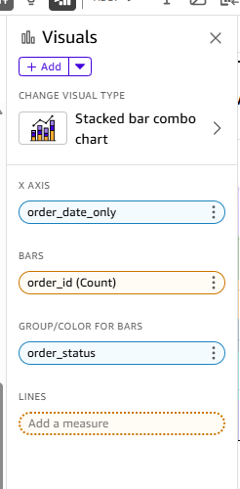
Statuses:
PLACED, CONFIRMED, SHIPPED, DELIVERED, CANCELLED, RETURNED
Instantly shows cancellations and delivery backlog
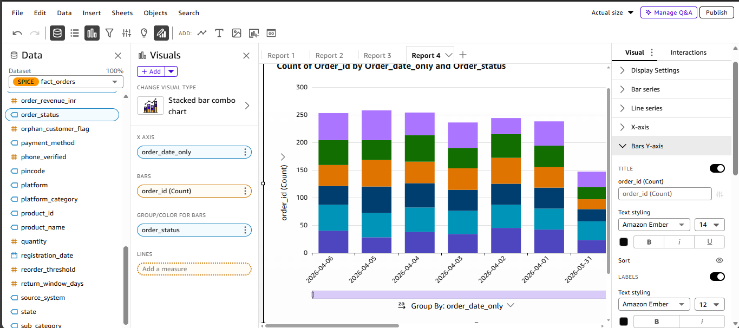
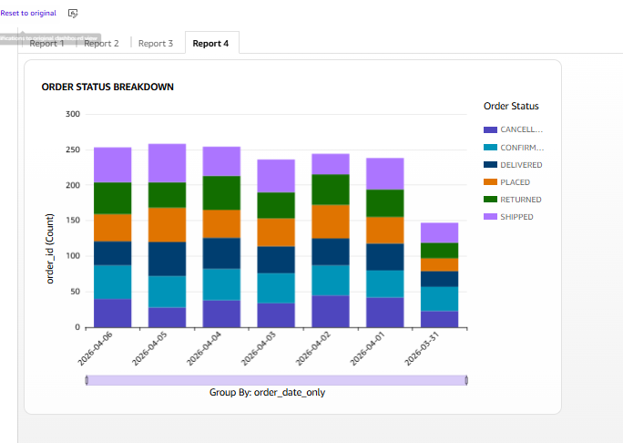
### REPORT 5 — GEOGRAPHIC REVENUE MAP
Dataset:
DS_Fact_Orders
Visual type: Filled map
- Location: delivery_state
- Value: SUM(order_revenue_inr)
- Filter: Last 30 days
Tooltip:
- State
- Total orders
- Total revenue
Uses delivery state, not customer state (PRD compliant)
======================================================================

STAGE 7 - Lambda function
STEP 1 — CREATE SQS QUEUE (MESSAGE PIPE)
SQS stores alert messages.
1.1 Open SQS
AWS Console → Search SQS → Click Simple Queue Service
1.2 Create Queue
Click Create queue
Fill:
Field | Value
Type | Standard
Name | ankita-retailpulse-alert-queue
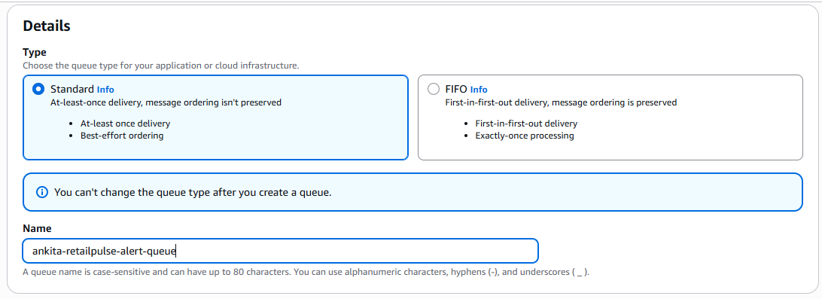
Leave everything else default
Click Create queue
ankita-retailpulse-alert-queue
Note this name (we will use it later)
STEP 2 — CREATE SNS TOPIC (EMAIL ALERTS)
SNS sends emails.
2.1 Open SNS
AWS Console → Search SNS → Click Simple Notification Service
2.2 Create Topic
Click Topics → Create topic
Fill:
Field | Value
Type | Standard
Name | ankita-retailpulse-alert-topic
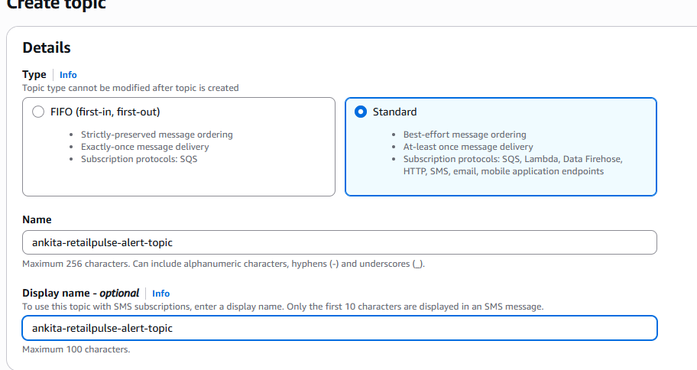
Click Create topic
2.3 Subscribe Email
Inside the topic → Click Create subscription
Fill:
Field | Value
Protocol | Email
Endpoint | your email id
Click Create subscription
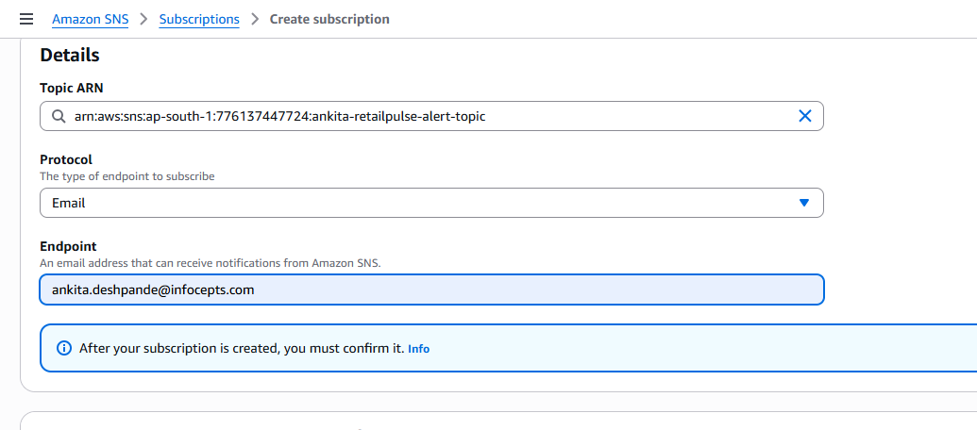
Check your email → Click Confirm Subscription
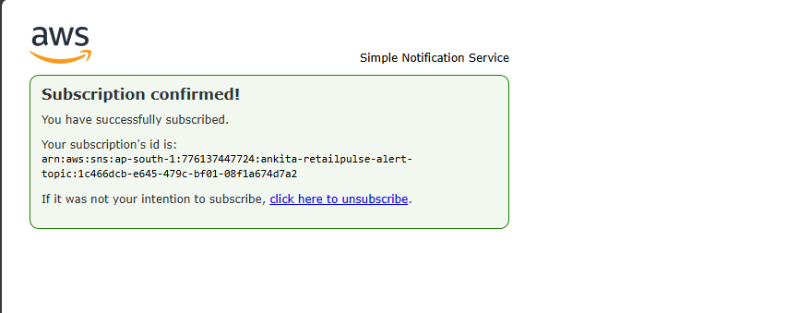
Status becomes: Confirmed
STEP 3 — CREATE RDS TABLES (ALERT HISTORY)
You already have RDS. Now we add alert tables.
3.1 Connect to RDS MySQL
From EC2 / laptop:
sudo dnf install mariadb105 -y
mysql -h ankita-retailpulse-mysql.c58qessmggt4.ap-south-1.rds.amazonaws.com -u admin -p
USE retailpulse;
3.2 Create Alert Tables
Alert Type 1
CREATE TABLE top_seller_stock_alerts (
alert_type VARCHAR(50),
severity VARCHAR(20),
product_id VARCHAR(30),
distributor_name VARCHAR(100),
region VARCHAR(50),
yesterday_revenue_inr DECIMAL(15,2),
closing_stock INT,
triggered_at TIMESTAMP
);
Alert Type 2
CREATE TABLE cancellation_alerts (
alert_type VARCHAR(50),
severity VARCHAR(20),
payment_method VARCHAR(30),
total_orders INT,
cancelled_orders INT,
cancellation_rate_pct DECIMAL(5,2),
cancelled_revenue_inr DECIMAL(15,2),
triggered_at TIMESTAMP
);
Alert Type 3
CREATE TABLE category_zero_order_alerts (
alert_type VARCHAR(50),
severity VARCHAR(20),
category VARCHAR(50),
triggered_at TIMESTAMP
);
Run:
SHOW TABLES;
You should see all 3 tables.
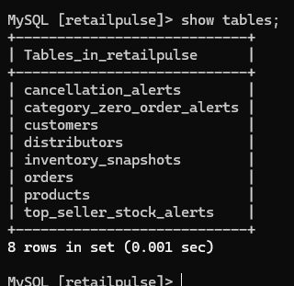
STEP 4 — CREATE IAM ROLE FOR LAMBDA (PERMISSIONS)
4.1 Open IAM
AWS Console → Search IAM
4.2 Create Role
IAM → Roles → Create role
Choose:
- Trusted entity type: AWS service
- Service: Lambda
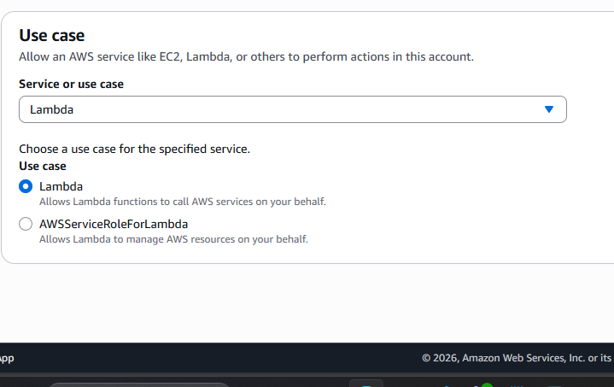
Click Next
4.3 Attach Policies
Select below policies:
- AmazonAthenaFullAccess
- AmazonS3FullAccess
- AmazonSQSFullAccess
- AmazonSNSFullAccess
- AmazonRDSFullAccess
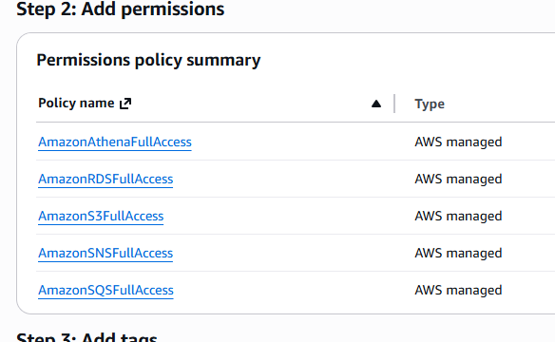
Click Next
4.4 Role Name
Role name:
ankita-RetailPulseAlertLambdaRole
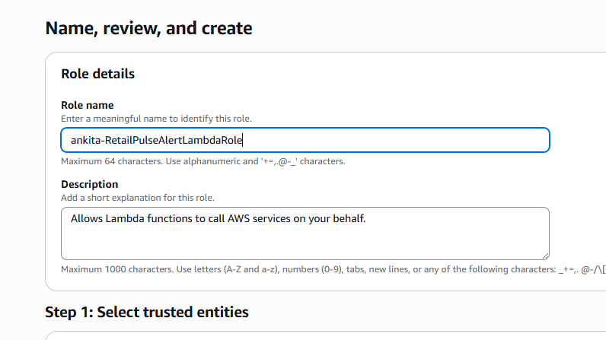
Click Create role
Role created
STEP 5 — CREATE LAMBDA FUNCTION (BRAIN)
Lambda runs Athena queries.
5.1 Open Lambda
AWS Console → Search Lambda
5.2 Create Function
Click Create function
Choose:
- Author from scratch
- Function name:
ankita-retailpulse-alert-lambda
- Runtime: Python 3.10
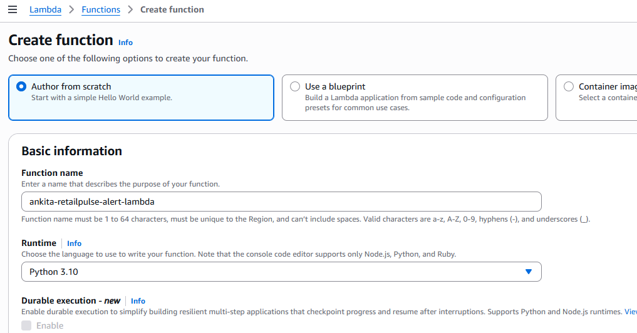
- Execution role: Use existing role
- Role: ankita-RetailPulseAlertLambdaRole
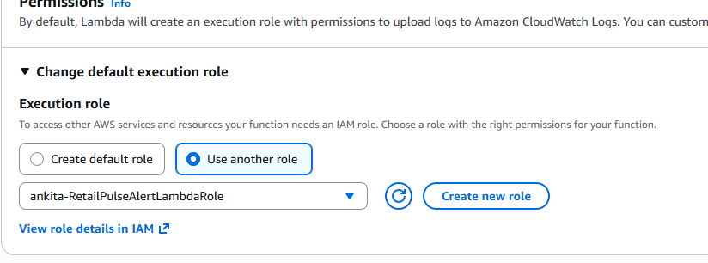
Click Create function
Lambda created
STEP 6 — ADD LAMBDA CODE (COPY–PASTE)
In Lambda → Code tab
Delete existing code and paste:
import boto3
import json
import time
import pymysql
from datetime import datetime

# =============================
# CONFIG
# =============================
ATHENA_DATABASE = "ankita-retailpulse_analytics"
ATHENA_OUTPUT = "s3://retailpulse-data-lake-ankita/athena-results/"

SQS_QUEUE_URL = "https://sqs.ap-south-1.amazonaws.com/776137447724/ankita-retailpulse-alert-queue"
SNS_TOPIC_ARN = "arn:aws:sns:ap-south-1:776137447724:ankita-retailpulse-alert-topic"

RDS_HOST = "ankita-retailpulse-mysql.c58qessmggt4.ap-south-1.rds.amazonaws.com"
RDS_USER = "admin"
RDS_PASSWORD = "12345678"
RDS_DB = "retailpulse"

# =============================
# AWS CLIENTS
# =============================
athena = boto3.client("athena")
sqs = boto3.client("sqs")
sns = boto3.client("sns")

# =============================
# HELPERS
# =============================

def run_athena_query(query):
print("Starting Athena query...")
response = athena.start_query_execution(
QueryString=query,
QueryExecutionContext={"Database": ATHENA_DATABASE},
ResultConfiguration={"OutputLocation": ATHENA_OUTPUT}
)
print("QueryExecutionId:", response["QueryExecutionId"])
return response["QueryExecutionId"]

def wait_for_query(query_execution_id):
print("Waiting for Athena query to complete:", query_execution_id)
while True:
response = athena.get_query_execution(
QueryExecutionId=query_execution_id
)
status = response["QueryExecution"]["Status"]["State"]

if status == "FAILED":
print("Athena FAILED reason:",
response["QueryExecution"]["Status"].get("StateChangeReason"))

if status in ["SUCCEEDED", "FAILED", "CANCELLED"]:
return status

time.sleep(3)

def fetch_results(query_execution_id):
paginator = athena.get_paginator("get_query_results")
rows = []

for page in paginator.paginate(QueryExecutionId=query_execution_id):
rows.extend(page["ResultSet"]["Rows"])

# Skip header row
data_rows = rows[1:]
parsed = []

for row in data_rows:
parsed.append([col.get("VarCharValue") for col in row["Data"]])

return parsed

def send_alert(message):
sqs.send_message(
QueueUrl=SQS_QUEUE_URL,
MessageBody=json.dumps(message)
)

sns.publish(
TopicArn=SNS_TOPIC_ARN,
Subject="RetailPulse CRITICAL ALERT",
Message=json.dumps(message, indent=2)
)

def get_rds_connection():
return pymysql.connect(
host=RDS_HOST,
user=RDS_USER,
password=RDS_PASSWORD,
database=RDS_DB
)

# =============================
# LAMBDA HANDLER
# =============================

def lambda_handler(event, context):

triggered_at = datetime.now().strftime("%Y-%m-%d %H:%M:%S")

rds_conn = get_rds_connection()
cursor = rds_conn.cursor()

# ======================================================
# ALERT TYPE 1 — TOP SELLER ZERO STOCK
# ======================================================
alert1_sql = """
WITH top_20_products AS (
SELECT product_id, SUM(order_revenue_inr) AS yesterday_revenue
FROM fact_orders
WHERE order_date_only = date_format(date_add('day', -1, current_date), '%Y-%m-%d')
GROUP BY product_id
ORDER BY yesterday_revenue DESC
LIMIT 20
)
SELECT
i.product_id,
d.distributor_name,
d.region,
t.yesterday_revenue,
i.closing_stock
FROM dim_inventory_snapshots i
JOIN top_20_products t ON i.product_id = t.product_id
JOIN dim_distributors d ON i.distributor_id = d.distributor_id
WHERE i.snapshot_date = current_date
AND i.closing_stock = 0
"""

qid = run_athena_query(alert1_sql)
if wait_for_query(qid) == "SUCCEEDED":
results = fetch_results(qid)
for r in results:
msg = {
"alert_type": "TOP_SELLER_ZERO_STOCK",
"severity": "CRITICAL",
"product_id": r[0],
"distributor_name": r[1],
"region": r[2],
"yesterday_revenue_inr": float(r[3]),
"closing_stock": int(r[4]),
"triggered_at": triggered_at
}
send_alert(msg)
cursor.execute(
"INSERT INTO top_seller_stock_alerts VALUES (%s,%s,%s,%s,%s,%s,%s,%s)",
tuple(msg.values())
)
rds_conn.commit()

# ======================================================
# ALERT TYPE 2 — HIGH CANCELLATION RATE
# ======================================================
alert2_sql = """
SELECT
payment_method,
COUNT(*) AS total_orders,
SUM(CASE WHEN order_status='CANCELLED' THEN 1 ELSE 0 END) AS cancelled_orders,
ROUND(SUM(CASE WHEN order_status='CANCELLED' THEN 1 ELSE 0 END)*100.0/COUNT(*),2) AS cancellation_rate,
SUM(CASE WHEN order_status='CANCELLED' THEN order_revenue_inr ELSE 0 END) AS cancelled_revenue
FROM fact_orders
WHERE order_date_only = date_format(current_date, '%Y-%m-%d')
GROUP BY payment_method
HAVING cancellation_rate > 25
"""

qid = run_athena_query(alert2_sql)
if wait_for_query(qid) == "SUCCEEDED":
results = fetch_results(qid)
for r in results:
msg = {
"alert_type": "HIGH_CANCELLATION_PAYMENT_METHOD",
"severity": "CRITICAL",
"payment_method": r[0],
"total_orders": int(r[1]),
"cancelled_orders": int(r[2]),
"cancellation_rate_pct": float(r[3]),
"cancelled_revenue_inr": float(r[4]),
"triggered_at": triggered_at
}
send_alert(msg)
cursor.execute(
"INSERT INTO cancellation_alerts VALUES (%s,%s,%s,%s,%s,%s,%s,%s)",
tuple(msg.values())
)
rds_conn.commit()

# ======================================================
# ALERT TYPE 3 — CATEGORY ZERO ORDERS
# ======================================================
alert3_sql = """
WITH today_categories AS (
SELECT DISTINCT category
FROM fact_orders
WHERE order_date_only = date_format(current_date, '%Y-%m-%d')
)
SELECT c.category
FROM (
SELECT 'ELECTRONICS' category UNION ALL
SELECT 'FASHION' UNION ALL
SELECT 'GROCERY' UNION ALL
SELECT 'HOME' UNION ALL
SELECT 'BEAUTY'
) c
LEFT JOIN today_categories t ON c.category = t.category
WHERE t.category IS NULL
"""

qid = run_athena_query(alert3_sql)
if wait_for_query(qid) == "SUCCEEDED":
results = fetch_results(qid)
for r in results:
msg = {
"alert_type": "CATEGORY_ZERO_ORDERS",
"severity": "CRITICAL",
"category": r[0],
"triggered_at": triggered_at
}
send_alert(msg)
cursor.execute(
"INSERT INTO category_zero_order_alerts VALUES (%s,%s,%s,%s)",
tuple(msg.values())
)
rds_conn.commit()

cursor.close()
rds_conn.close()

return {"status": "All alerts evaluated"}
Click Deploy
6.1 Fill the placeholders
- SQS URL → copy from SQS console
- SNS ARN → copy from SNS topic
STEP 7 — TEST LAMBDA MANUALLY
Click Test
Choose:
- Event name: test
- Event JSON:
{}
Click Test
Expected:
- Lambda success ✅
- Message appears in SQS
- Email received ✅
STEP 1 — FIX YOUR CURRENT SYNTAX ERROR (YOU ALREADY SAW THIS)
You already fixed the markdown/backticks issue — good
Your Python syntax is now valid
Next error you’ll hit (expected):
ModuleNotFoundError: No module named 'pymysql'
That’s what we fix now.
STEP 2 — CREATE A LAMBDA LAYER FOR pymysql (MOST IMPORTANT)
2.1 Open an EC2 or Your Local Laptop
Use:
- ✅ Same EC2 you used earlier, or
- ✅ Your laptop (Linux / Mac preferred)
2.2 Create Layer Folder Structure
mkdir pymysql_layer
cd pymysql_layer
mkdir python
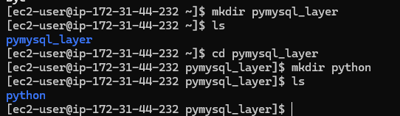
Lambda requires this folder name exactly.
2.3 Install pymysql into the Layer
sudo yum update -y
sudo yum install python3-pip -y
pip3 --version
Run:
pip install pymysql -t python/
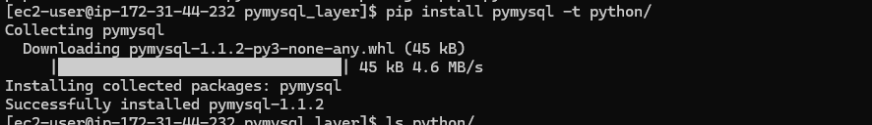
Verify:
ls python/
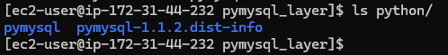
You should see:
pymysql/
PyMySQL-*.dist-info/
2.4 Zip the Layer
From inside pymysql_layer:
zip -r pymysql_layer.zip python
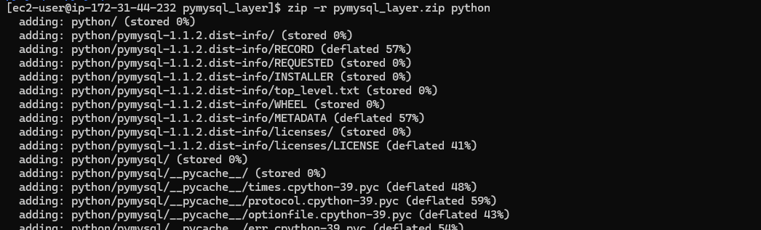
ZIP file created:
pymysql_layer.zip
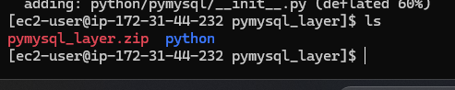
Download zip file to local machine
scp -i ankita_keypair.pem ec2-user@52.66.7.170:/home/ec2-user/pymysql_layer/pymysql_layer.zip .
STEP 3 — CREATE THE LAMBDA LAYER IN AWS
3.1 Open Lambda Console
AWS Console → Search Lambda
3.2 Go to Layers
Left menu → Layers → Create layer
3.3 Fill Details
Field | Value
Name | ankita-pymysql-layer
Upload | Upload pymysql_layer.zip
Runtime | ✅ Python 3.10
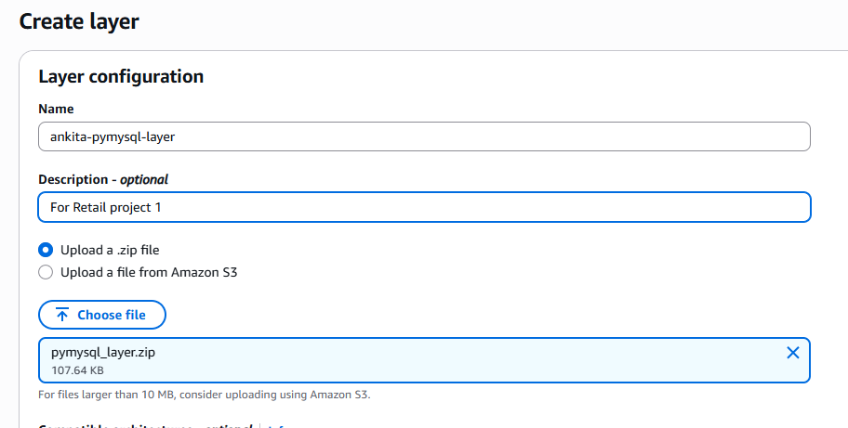
Click Create
Layer created successfully
STEP 4 — ATTACH LAYER TO YOUR LAMBDA FUNCTION
4.1 Open Your Lambda Function
ankita-retailpulse-alert-lambda
4.2 Add Layer
Scroll to Layers → Click Add a layer
Choose:
- Custom layers
- Select pymysql-layer
- Version 1
Click Add
Lambda now has pymysql
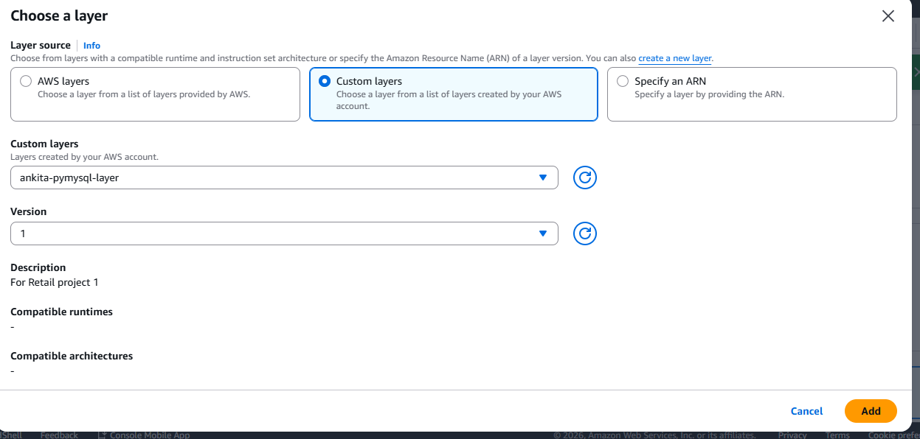
STEP 5 — VERIFY IAM ROLE (ONE QUICK CHECK)
Your Lambda role must have:
- AmazonRDSFullAccess
- AmazonAthenaFullAccess
- AmazonSNSFullAccess
- AmazonSQSFullAccess
Change below configurations:
Timeout: 2 minutes
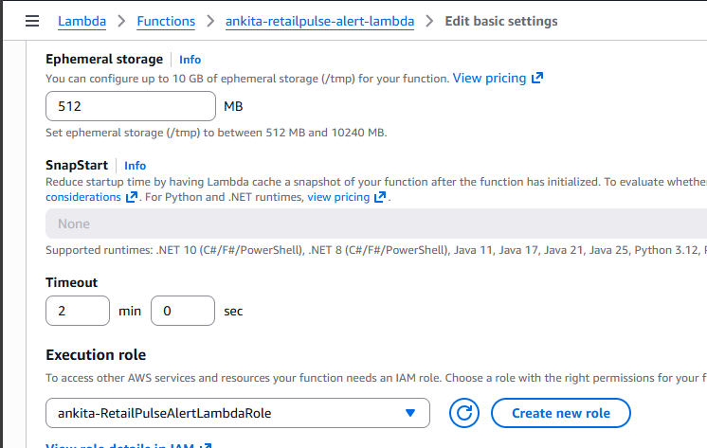
Increase memory
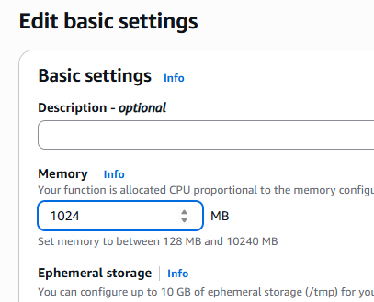
STEP 7 — FINAL LAMBDA TEST (THIS WILL WORK)
- Click Deploy
- Click Test
- Test event:
{}
Expected Results
✔ Lambda finishes successfully
✔ Athena query executes
✔ Message appears in SQS
✔ Email arrives via SNS
✔ Rows inserted in RDS tables
Check RDS:
SELECT * FROM top_seller_stock_alerts;
SELECT * FROM cancellation_alerts;
SELECT * FROM category_zero_order_alerts;
Mail received
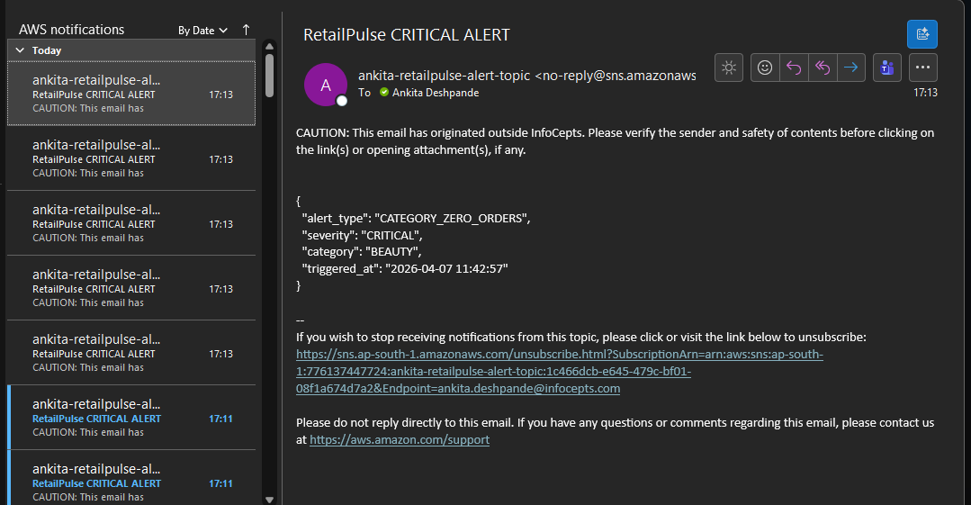
CSV file in s3 bucket
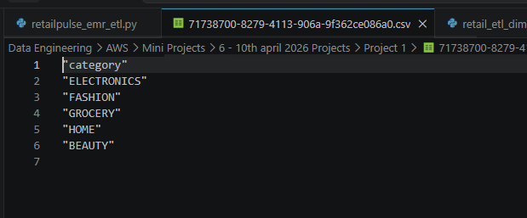
STEP-BY-STEP: EventBridge Schedule at 6:25 PM IST
Step 1 — Open EventBridge Schedules
- Go to AWS Console
- In the search bar, type EventBridge
- Click Amazon EventBridge
You’ll see multiple options.
In the left-hand menu, click:
Schedules
Step 2 — Create a New Schedule
- Click Create schedule
- You’ll be taken to the schedule creation page
Step 3 — Basic Schedule Details
Fill these fields:
Field | What to enter
Name | ankita-retailpulse-alert-schedule-625pm-ist
Description | Run RetailPulse alert Lambda daily at 6:25 PM IST
Schedule group | default
Click Next
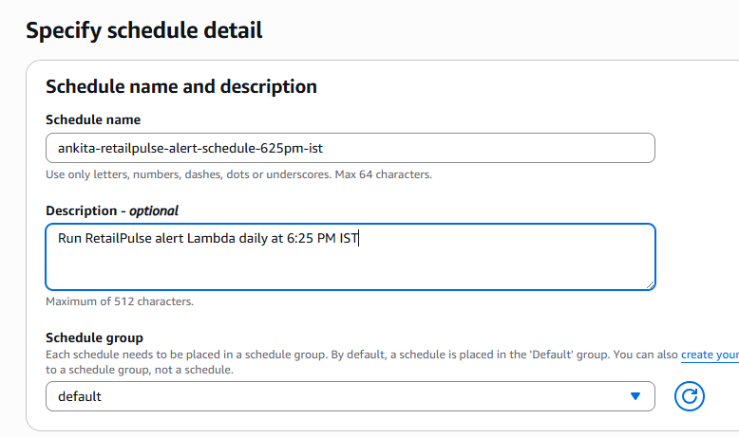
Step 4 — Choose Schedule Type
You’ll see scheduling options.
- Select One-off schedule
